
[Open and Secure Digital object Rights Management ]

OpenSDoRM API Specification
Identifier: | DoRM-APISPEC
Pages: | 110
Version: | 2005.10.11
Access: | Private
State: | Work in Progress
Distribution: | Internal to the project
Disclaimer:
The contents of this document are under copyright of ADETTI. It is released on condition that it shall not be copied in whole, in part or otherwise reproduced (whether by photographic, or any other method) and the contents therefore shall not be divulged to any person other than that of the addressee (save to other authorized offices of his organization having need to know such contents, for the purpose for which disclosure is made) without prior written consent of submitting company.

Table of Contents

Table of Contents 2
Purpose 5
Introduction 5
The OpenSDoRM platform 5
OpenSDoRM components 5
User Roles 7
External Entities 7
DRM Entities 7
Technical Architecture Description 8
External Components & Interfaces 8
Internal Components & Interfaces 9
OpenSDoRM Security 10
Device Identification and Authentication 11
Server Components Certification 13
Registration of Components on OpenSDoRM 13
User’s registration on the OpenSDoRM platform 15
Components message exchange 16
Payment information 17
Paying services with OpenSDoRM 18
License Production 19
License Download 20
License Expiry 20
Services Description 20
AUS – Authentication Service 20
Description 20
Function List Overview 20
Function List Detailed 21
Examples 27
CFS – Configuration Service 27
Description 27
Function List Overview 27
Function List Detailed 27
Examples 28
ITS – Protection Tools Service 28
Description 28
Function List Overview 28
Function List Detailed 29
Examples 30
LIS – License Service 30
Description 30
Function List Overview 30
Function List Detailed 31
Examples 34
MDS - Media Delivery Service 34
Description 34
Function List Overview 34
Function List Detailed 34
Examples 36
PGW - Billing Service 36
Description 36
Function List Overview 36
Function List Detailed 37
Examples 38
RGS – Registration Service 38
Description 38
Function List Overview 38
Function List Detailed 39
Examples 41
Annex – WSDL descriptions of all the services 41
AUS – Authentication Service 41
CFS – Configuration Service 58
ITS – Protection Tools Service 62
LIS – License Service 68
MDS – Media Delivery Service 79
PGW – Billing Service 87
RGS – Registration Service 92
Annex – Relational Database schema 100
AUS – Authentication Service 100
CFS – Configuration Service 101
COS – Commerce Service 102
CPS – Content Preparation Service 103
ITS – Protection Tools Service 103
LIS – License Service 104
MDS – Media Delivery Service 106
PGW – Billing Service 107
RGW – Registration Service 108

Purpose
The purpose of this document is to provide a description of the OpenSDoRM DRM system architecture components and the functions which are associated to them. Its main aim is to provide a guideline for someone wishing to DRM-enable some system or application to be able to do so and integrate it with the OpenSDoRM platform.
OpenSDoRM deals with the rights management and not directly with the copy protection tools or mechanisms. It is independent of the protection mechanisms being applied to the content. Therefore it is out of the scope of this document to talk about how the content gets protected or how the content is formatted.

Introduction

The OpenSDoRM platform
This section of the document details the OpenSDoRM rights management platform, presenting details about its conceptual architecture as well as it provides the description of both the external and internal OpenSDoRM components.
This section is divided in two different parts: the first part describes both the conceptual architecture as well as the different components, while the second provides an in-depth vision of the security of the OpenSDoRM system.

OpenSDoRM components
The OpenSDoRM rights management platform is composed of a set of distributed components that exchange standardized messages over open networks (such as Internet). The OpenSDoRM conceptual architecture (presented on the following picture) defines a scenario capable of handling a multiplicity of different business models for content distribution.
This conceptual architecture lies on three different building blocks: the user (not necessarily the end-users) roles; a set of external entities to the DRM process itself; and the internal DRM entities which provide the DRM functionalities.

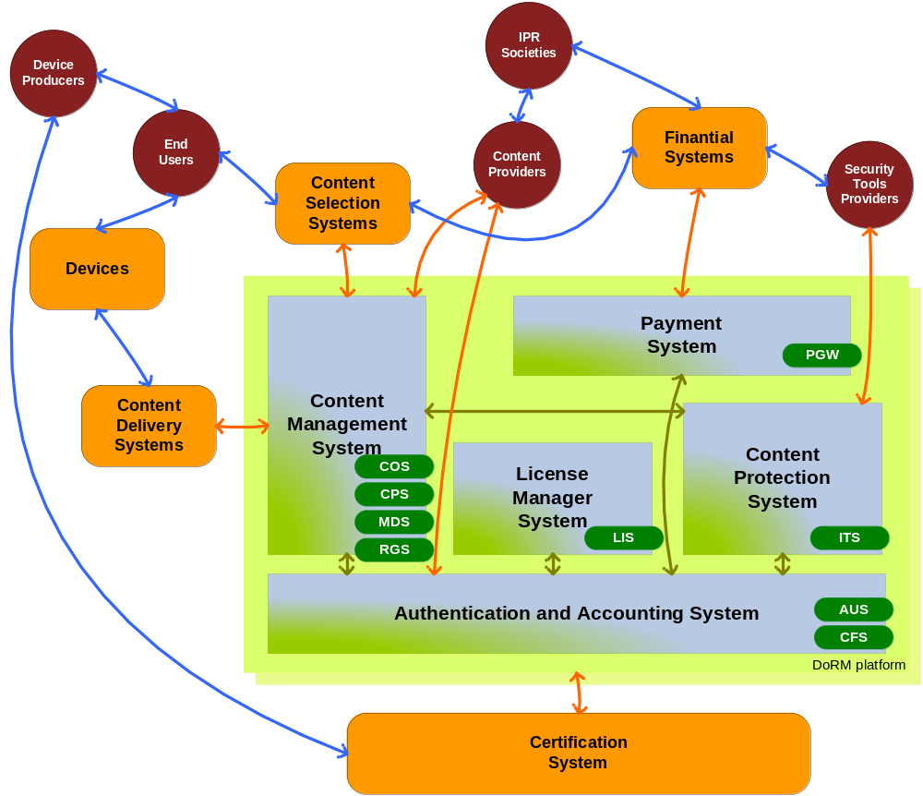

User Roles
These are the roles that are represented by the several entities on the content value-chain. It is important not to mistake these User roles, with end-user roles. The OpenSDoRM framework identifies several of these user roles:
- Author/Owner Societies: these are the societies that are responsible for upholding the copyright on the content and to ensure the revenue of the content author. Examples of such entities are for instance the SPA (Portuguese Author’s Society), in Portugal.
- Content Providers: these represent the content authors which produce creative work and that distribute it over some digital medium. Additionally the content authors will be able to define the terms and the conditions under which their content may or may not be used.
- Device Producers: they represent device manufacturers (which may be hardware, software or both) that produce content rendering devices capable of enforcing DRM/CP-related functions on content usage. These device manufacturers can be certified by the DRM platform.
- Security Tools Providers: in order to ensure interoperability among the different content formats and different protection technologies, there must be some technology that may allow a given device to adapt its capabilities to the type of content it is trying to render. These entities provide the technological means for a rendering device to adapt its security features to the type of protection technology enforced upon a given content.
- End Users: these represent the final users that want to select and use the content. Usage of the content at this stage is always controlled by client DRM modules.

External Entities
These entities, represented on the conceptual model, support the non-DRM functions on the architecture. These entities are: Payment Infrastructure, Content Selection Modules, Devices, Content Delivery Servers and the Certification System.
- Payment Infrastructure: this external entity is responsible for handling all the financial transactions, and to assure that the appropriate content value-chain players receive the appropriate incoming for their effort;
- Content Selection Modules: this is either an external entity or module that can be used to find, browse and select content. Examples of such modules are for instance an Electronic Commerce front-store or an Electronic Program Guide;
- Devices: the devices are mechanisms that allow the final users to enjoy content they obtained.
- Content Delivery Servers: this entity represents the servers that will be feeding the content to the final users, or its owned devices.
- Certification System: this is an external (although it can also be internal) entity that issues the appropriate credentials for all components’ certification.

DRM Entities
These entities provide on the OpenSDoRM conceptual model the DRM-enabling elements on the system. It is these elements (both server and client-side) that will provide the necessary DRM functionalities to protect the content and to uphold the rights associated to that content and user. The entities are: Content Management System, Payment Gateway Module, License Manager System, Content Protection Tools System and the Authentication and Accounting System. More details about each element provided by the conceptual DRM entities are provided on the technical architecture description.
Figure 1 - OpenSDoRM main elements

Technical Architecture Description
OpenSDoRM is, overall, a distributed architecture. Has such, all its elements communicate with each other through the use of a set of well-known interfaces, published here in the form of WSDL. Special security considerations are taken into account assuring the secure communication of every component on the platform.
The whole infrastructure was designed with the concern to be adaptable and applicable to all types of content and business models (download, super-distribution, streaming or even broadcasting).
The diagram below shows the complexity of intercommunication between the elements in the platform. Process and data flows represented in orange are interactions with external entities, while process and data flows represented in green are internal interactions. Each of these interactions is well documented below, in the Services Description section.

External Components & Interfaces
This part will present in detail the components and actors that may interact externally with the OpenSDoRM architecture, namely, the User, the IPMP Tools Provider, the Content Provider, the Payment Infrastructure and the Certification Authority.
- The User represents a person who wishes to consume a piece of content. This content may or may not be protected. However the way to access and display such content may require the use of protected devices, software and licenses. The user will make requests to Open SDRM in order to: identify him, download licenses and play multimedia using a Media Player, embedded or not on a web browser. In a final analysis, the User interaction with OpenSDoRM will always result in one of two things: either the user can play/render the content and enjoy it or he/she can’t; being then informed of the reason for this prevention.
- The IPMP Tools Provider is any organization that produces tools and technologies for encryption, scrambling, watermarking and others that can be applied to content protection. These tools will be made available to OpenSDoRM for use in content rights protection. These tools will need to comply with some guidelines. These guidelines and a subscription, are translated into a business relation that must exist between a given Content Provider and the IPMP Tools Provider, since mostly, a given producer and/or distributor of content, may want to choose which type of protection the content will have and, respectively, which tools can be applied to the content and from which supplier.
- The Content Provider is any multimedia content supplier that feeds OpenSDoRM with content and optional metadata. The content can be complex multimedia content that is ready for distribution, or simple content, for example JPEG images, that can be edited and combined with other content. As the mentioned, the MOSES project has addressed MPEG-4 content.
- The Payment Infrastructure facilitates OpenSDoRM e-commerce features by providing services for handling electronic payments. The interface between OpenSDoRM and the Payment Infrastructure is generic and independent of the payment method, allowing therefore a multiplicity of payment systems.
- The Certification Authority is responsible for receiving requests for and issuing credentials to entities. These credentials will be used by entities to authenticate themselves to each other, allowing the establishment of secure and authenticated communication channels between them. All the components in the OpenSDoRM architecture communicate using the channel security provided by the SSL/TLS protocol. This Certification Authority may be internal to OpenSDoRM, and therefore entirely managed by some entity, or it may be an external commercial Entity.

Internal Components & Interfaces
In this part, the internal components of the OpenSDoRM platform and the corresponding interfaces are presented. These components include: Media Application, Media Delivery Server, Commerce Server, Authentication Server, License Server, IPMP Tools Server, Registration Server, Content Preparation Server and the Payment Gateway.
- Content Preparation server (CPS): this server component is responsible for the content preparation. It receives raw content from a specified source or sources and encodes it on a specified format, adds metadata and protects it. Under the MOSES project, content has been encoded in MPEG-4 format, according to some pre-established templates. These templates will allow the creation of MPEG-4 files containing music files in MP3 or AAC format together with some JPEG images about the album and artist.
- Payment Gateway (PGW): is a server component responsible for verifying and validating the payment methods provided by the User for a Commerce Server;
- Commerce server (COS): is a server component responsible for trading the content with the users. Normally, content is chosen via web browser, some very generic metadata might be consulted, information about the price is also available, and especially the content usage conditions might be established.
- Media Delivery server (MDS): is a server component responsible for exchanging pieces of content with the client. This Media Delivery server will implement a specific protocol (download: FTP, HTTP or other; streaming: RTSP or other; broadcast) to exchange protected content with the client Media Application.
- Registration server (RGS): is a server component whose role is to assign unique identifiers to content and to register metadata information for that specific content. This architecture was designed to be as close as possible to ISO standards and therefore, for this unique ID, OpenSDoRM follows the MPEG-21 directives about Digital Item Identification (DII), using a reduced version of the MPEG-21 DII Digital Object Identifiers (DOI).
- Authentication server (AUS): is responsible for authenticating all the internal and external entities to the DRM system. It validates the access rights of all the entities and components in the system working as a SSO point, registering and managing components and users on the system. It uses cryptographic XML credentials to authenticate both components and users in order to authenticate the transactions exchanged between them (XML Encryption and XML Signatures).
- License server (LIS): is a server component responsible for house-keeping the rules associating a user, the content and his/her corresponding access rights. This component will accept connections from authenticated Media Players clients for downloading of licenses, which will be applied to the protected content through an appropriate IPMP tool. The licenses are XML formatted using Open Digital Rights Language (ODRL/OMA profile) or the Rights Expression Language (REL), developed by MPEG-21.
- IPMP tools server (ITS): is the server component responsible for registering new IPMP tools and for receiving authenticated client Media Application requests for the downloading of a specific IPMP tool. It is also responsible for making IPMP tools available to the Content Preparation Server to allow the protection of content.
- Media Application (MPL) This component represents the software that will be used to render the content. This is a generic component with the particularity of being able to display/playback the appropriate content for which the necessary audio/video codec should be available (if this codec is not available it must be downloaded from a remote secure server). This Media Application may work with one or several IPMP tools in order to control how the content is accessed by a particular user. This component works on the client side of the general architecture; however it plays an important role in the DRM functions. The Media Application design is fully compatible with the IPMPX design and took in consideration that content can be exchanged on-line and off-line as well, since it supports the "Tools in Content" functionality where Content, Tools and Licenses can be packaged and distributed i.e. via Bluetooth together to a certain device.

OpenSDoRM Security
The distributed nature of OpenSDoRM was already mentioned. As such, and inherently to present day communications, all communication between each component of the platform will usually take place within insecure networks. Furthermore the components communicate with a text-based protocol. This introduces special needs regarding the security of this communication.
An underlying concept behind the OpenSDoRM platform is the existence of two security layers as displayed below. A first security layer is established at the communication level, which will provide the necessary secure and authenticated communication medium to components to communicate with each other. A second layer is established at the application level, ensuring the security, integrity, authentication and non-repudiation mechanisms needed by the different components.

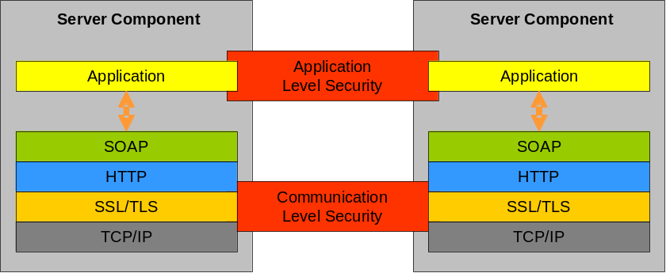
Figure 2 - OpenSDoRM Security Layers
Each of the messages exchanged between the different components share a common structure. The format as shown below is composed of:
- Component ID: a 128 bits identifier (generated by an MD5 hashing algorithm) that identifies uniquely this component. This identifier was issued by the AUS;
- Message Contents: this is a set of different fields of the message, and typically it is different from component to component;
- Digital Signature: the digital signature of the message, to avoid the message contents tampering.

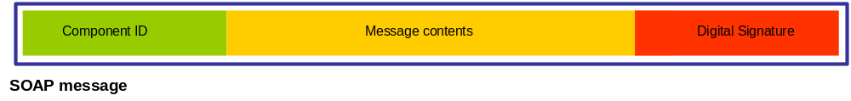
Figure 3 - SOAP Message Structure

Device Identification and Authentication
A device is a piece of hardware and/or software with the capability to play audio-visual content. The device can be used by used only by one user (if we consider for instance a personal mobile phone or a portable MP3 player) or by several users (a set-top box in the case of Interactive TV). Therefore in our platform, there must be two levels of authentication - the device must be authenticated, and each of the users that use the device must also authenticate.
In what concerns to the device identification and authentication, the Device Manufacturer places a digital credential inside the device. This credential is an X509 certificate obtained from a trustworthy Certification Authority (CA). So every Device Manufacturers (DMan) put on their devices, their own certificates. Off course, a first step must occur, that is that each of the DMan must be certified by a ROOT CA (rCA).
So, each DMan have their own device manufacturer certificates:
Cert_{rCA}^{DMan[1]}, Cert_{rCA}^{DMan[2]}, ..., Cert_{rCA}^{DMan[n]}
And each Devices (Dev) also have their own Certificates:
Cert_{DMan[1]}^{Dev[1]}, Cert_{DMan[1]}^{Dev[2]}, ..., Cert_{DMan[1]}^{Dev[n]}
Cert_{DMan[2]}^{Dev[1]}, Cert_{DMan[2]}^{Dev[2]}, ..., Cert_{DMan[2]}^{Dev[n]}
...
Cert_{DMan[n]}^{Dev[1]}, Cert_{DMan[n]}^{Dev[2]}, ..., Cert_{DMan[n]}^{Dev[n]}
In that way, when two devices wish to communicate, or even a device wishes to communicate with any other component, they can trust each other just by presenting their credentials/certificates to each other (performing a mutual authentication). The mutual authentication will succeed if they all share the same rCA.
Therefore for any Cert_{DMan[n]}^{Dev[n]} the authentication will succeed if the issuer of the certificate (Device Manufacturer) have on their certification path/chain a common certificate issued by the same rCA.
Basically what we have is two roles:
- One major entity (ROOT CA) delegates its trust on the Device Manufacturers, saying to the rest of the world that the Device Manufacturer is trustworthy;
- The Device Manufacturer puts its trust on the Device supplied to the User.
This is a normal certification mechanism that currently exists and that is widely deployed, especially on the Internet (for instance in SSL/TLS protocol) and using PKI mechanisms.
The mutual authentication mechanisms works in the following manner:
- Device A (Dev[a]) sends its certificate (Cert_{DMan[x]}^{Dev[a]}) to Device B (Dev[b]);
- Dev[b] sends its certificate to Dev[a] (Cert_{DMan[y]}^{Dev[b]});
- Dev[b] verifies the following:
  - If there is a common rCA certificate in the Dev[a] certificate chain;
  - If yes, validate the Dev[a] digital signature;
  - The certificate validity date;
- Dev[a] performs the same validations on Dev[b] certificate;
- Optionally Dev[a] and Dev[b] can challenge each other, like this:
  - Dev[a] selects a random number, and ciphers it with the Dev[b] public-key;
  - Dev[b] receives it and deciphers it using their private-key. Dev[b] ciphers the result of the previous operation with the public-key of Dev[a];
  - Dev[a] receives the data and deciphers it with the corresponding private-key. If the result is equal to the first selected number, then the mutual authentication succeeds.
- Conclusion of the mutual authentication.
Therefore, the identification of the device is provided by the certificate that is placed on the device by the Device Manufacturer. This certificate contains also information about a common rCA that enables the trust between different devices from different Device Manufacturers. At the same time, this device certificates are used for device authentication as well.

Server Components Certification
In order to establish the secure transport layer, the software components of the OpenSDoRM architecture, use the SSL/TLS protocol to ensure such functionality. Each of the servers, on which the software components are installed, need to have a X.509 certificate issued by a Certification Authority (CAU). If more than one of the OpenSDoRM components are installed on the same server then such one of this certificates are necessary. The CAU can be operated internally by OpenSDoRM itself or can be an external and commercial one.
In this way, OpenSDoRM can establish an underlying secure and authenticated transport channel that will allow the messages to flow from component to component securely.
- Each component computes a key pair (public and private) , K_{pub}^{Server}, K_{priv}^{Server}, using the RSA algorithm and create Certificate Signing Request (CSR) using its public key and some additional information sending it after to the CAU
- The CAU verifies the CSR validity and issues the X.509 SSL certificate to the appropriate component, Cert_{X.509}^{Server};
- The X.509 SSL certificate is installed and the components can use SSL/TLS to communicate, establishing therefore the secure transport layer.
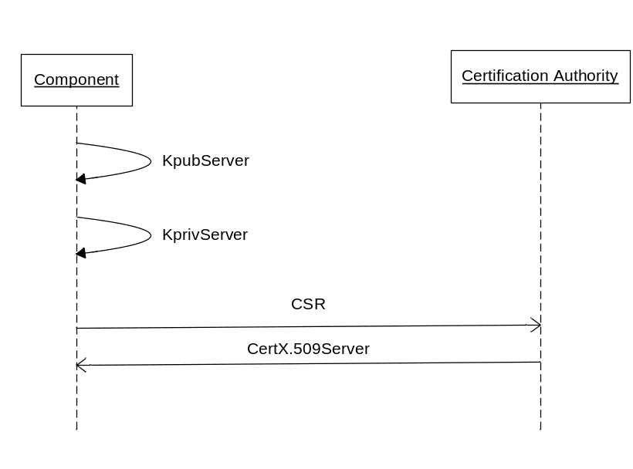
Figure 4 - Components certification process

Registration of Components on OpenSDoRM
The architecture requires that both components and Users on the OpenSDoRM architecture to be registered, in order to establish the Application/Transaction level security.
Concerning components (COS, PGW, RGS, LIS, ITS, CFS, MDS, CPS) those are registered on OpenSDoRM AUS. In order to complete this process the following steps are necessary, during the installation of each of the components:
- Each component computes a key-pair (currently OpenSDoRM uses a 1024 bit length RSA keys, but higher key lengths are also possible): Kpub^{Component}, Kpriv^{Component} (respectively the public and private keys);
- The component administrator selects a login and a password, and ciphers the Kpriv^{Component}, using AES, with the key (K_{AES}) deduced from the hash of the concatenation of the login and password selected: K_{AES} := MD5(login+password). The ciphered component private key gets then protected from unauthorized usage: K_{AES}[Kpriv^{Component}].
- The component then connects to the AUS and sends some registration information together with the Kpub^{Component}.
- AUS verifies the information sent by the component, validates and registers it, and issues a certificate for the component: Cert_{AUS}^{Component}. This certificate contains, among other information, a unique identifier of the component and the public key. This certificate is return to the component.
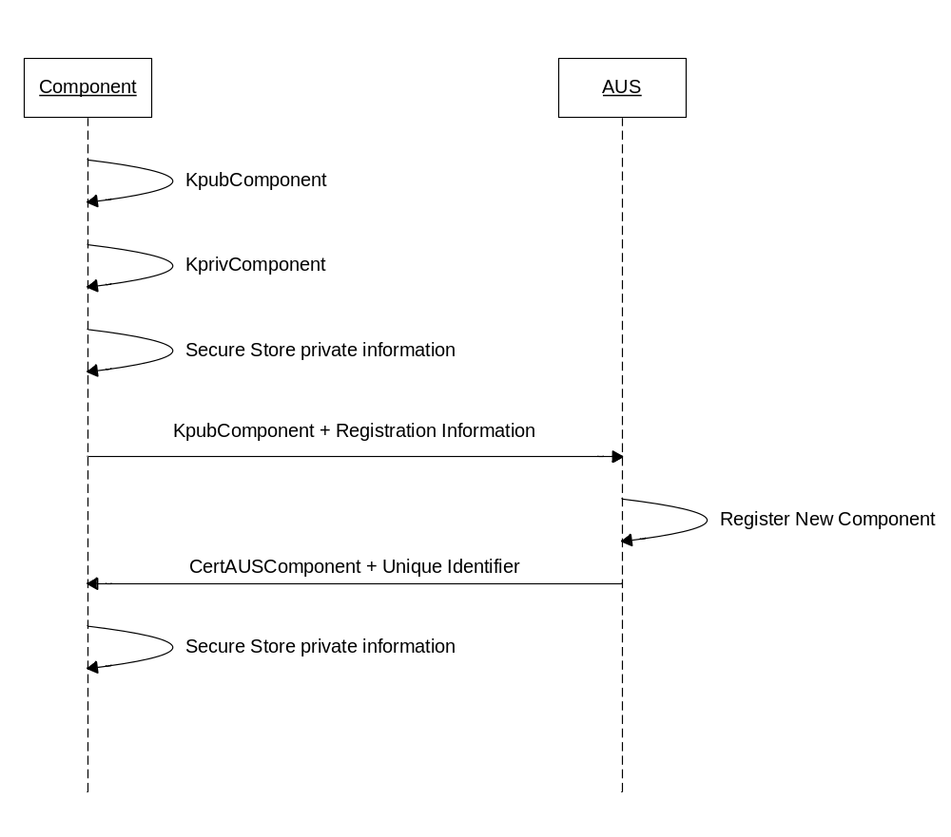
Figure 5 - Components registration process
With these component certificates, each of the components will be able to establish trust relationships among them and sign and authenticate all the transactions – this establishes then the Application Level security.

User’s registration on the OpenSDoRM platform
In OpenSDoRM three components interact directly with external users/entities – MPL, CPS and ITS. These users, respectively Content Users, Content Providers and IPMP Tools Providers are registered on the platform, through the AUS.
Content Providers and IPMP Tools Providers, subscribe respectively on the CPS and ITS, relying on the registration and authentication functionalities of the AUS. Therefore, when a new user subscribes, it provides some personal information, a login and password and requests the registration. The following processes can be described like this:
- The components (ITS and CPS) gather the new registrant information (Info) and request the registration of a new user on the AUS;
- The components build a new message: SignKpriv^{Component}{Component_{ID}, Info}. This message is send to AUS;
- AUS verifies and validates the message, registering the new User and returning a unique User_{ID} to the component.
Registering a Content User is a more complex process. This is due to the fact that while both Content Providers and IPMP Tool Providers have their information stored on remote servers, Content Users rely on their own platforms to store their data. In order to provide some additional degree of security, OpenSDoRM provides a digital wallet, capable of storing sensitive information such as cryptographic data and licenses in a secure way. The process to register new Content Users can be described in the following steps:
- When the user runs the wallet for the first time, it creates the User a RSA key pair (Kpriv^{User}, Kpub^{User}) and asks the user to enter a login and a password;
- Using the entered login and password, it creates the secure repository master key: K_{AES} = MD5(login+password), and stores sensitive information (Info) on it: K_{AES}[Info];
- The wallet asks the user to enter some personal data (Person_{Data}) and also some payment data (Pay_{Data}) used to charge the user for any commercial content usage;
- The wallet requests the AUS to register a new User, sending all the information ciphered with the AUS Kpub^{AUS}: Kpub^{AUS}[Person_{Data}, Pay_{Data}, KPriv^{User}, Kpub^{User}];
- AUS receives the data, deciphers it and registers the User. AUS responds to the Wallet with a new certificate generated for the User: Cert_{AUS}^{User}, containing among other information the unique identifier of the User, its public key, the identification of the AUS its signature;
- The wallet stores all the relevant information on the secure repository: K_{AES}[Cert_{AUS}^{User}].
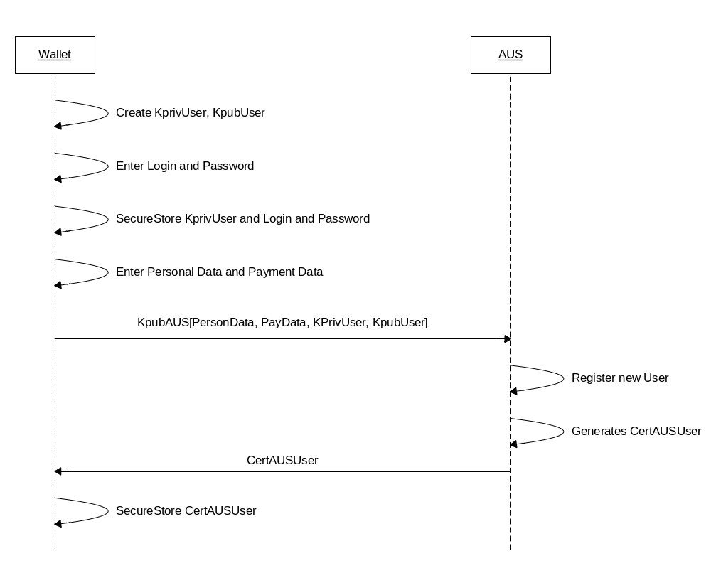
Figure 6 - Users registration process

Components message exchange
The process for the components to exchange messages and to verify the authenticity and validity of such messages is composed of the following steps:
- The sender component (CSender) composes a message using the following syntax: SignKpriv^{CSender}{CSender_{ID}, Payload, Cert_{AUS}^{CSender}};
- The receiver component (CReceiver) receives the message and verifies the trust on the message. This trustability is assured in the following way:
- CReceiver gets Cert_{AUS}^{CSender} and checks if it was issued by a AUS in which CReceiver trusts.
- This verification can be conducted if CReceiver has also a certificate issued by AUS: Cert_{AUS}^{CReceiver}.
- After the trust is established, the message signature can be verified and validated and CReceiver can trust its contents, and also in the component who has sent this message;
- CReceiver can then process the message payload and return its results for the CSender;
- CReceiver returns the following message to CSender: SignKpriv^{CReceiver}{CReceiver_{ID}, Results, Cert_{AUS}^{CReceiver}}.
This processing flow is displayed in the next picture.
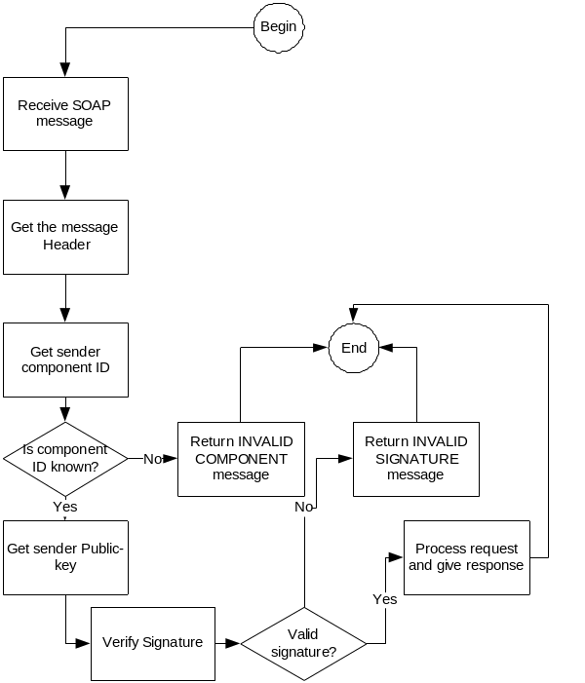
Figure 7 - Message security and integrity verification

Payment information
Payment of content usage is one of the questions that OpenSDoRM also deals and incorporates mechanisms for payment, although the payment method is outside the scope of the OpenSDoRM itself.
To provide this functionality a direct trust relationship must be established between the COS and the PGW. Therefore the COS (that relies on the payment functionalities) needs to subscribe a PGW. The process to subscribe a PGW can be described as the following:
- The COS connects to the AUS and asks the AUS which are the PGW available on the system. COS sends SignKpriv^{COS}{COS_{ID}, RequestAvailablePGWs} to AUS;
- AUS verifies the message, and returns an answer to the COS: SignKpriv^{AUS}{<ListOfAvailablePGWs, Cert_{AUS}^{PGW}>};
- The COS selects one available PGW and sends to it a subscription request: SignKpriv^{COS}{AUS_{ID}, SubscribePGW, Cert_{AUS}^{COS}};
PGW receives the request from the COS, validates its request and subscribes the COS. Therefore, this PGW will be used to validate and process payments used by a given User.
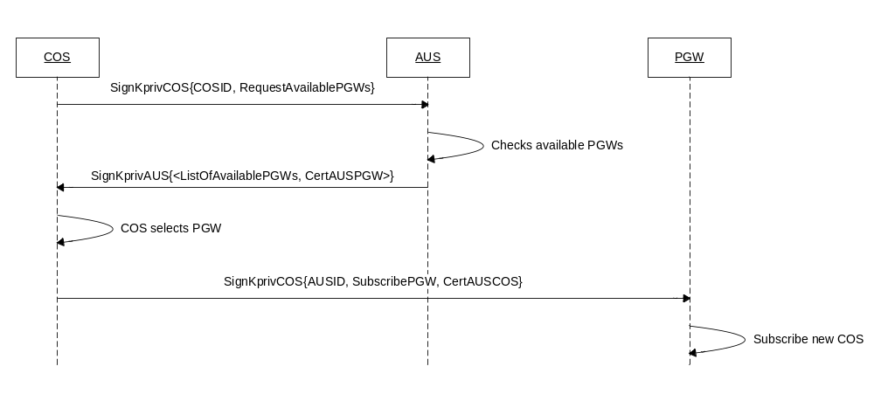
Figure 8 - Payment gateway subscription process

Paying services with OpenSDoRM
Using the payment service provided in OpenSDoRM involves two steps: validating the payment instrument and capturing the payment.
Validating the payment instrument is an important step on the system, since it will allow the COS to be sure that the payment method supplied by the user is authentic and valid, and that the transaction can be conducted without problems. Validating the payment involves the following steps:
- The COS sends information about the payment details, namely information about the User order and the price to pay for it, to AUS: SignKpriv^{COS}{COS_{ID}, U_{ID}, PGW_{ID}, PayData};
- AUS verifies and validates the COS request and checks the UID in order to retrieve the appropriate payment method choose by the User upon registration on the AUS. This data is ciphered with the public key of the PGW: Kpub_{PGW}[PaymentClearence_{U}];
- The AUS returns this information for the COS, signing it: SignKpriv_{AUS}{Kpub_{PGW}[PaymentClearence_{U}]};
- This information is then passed by the COS to the PGW, requesting it to validate the payment transaction: SignKpriv_{COS}{COS_{ID}, Kpub_{PGW}[PaymentClearence_{U}]};
- PGW validates the message and deciphers the User payment clearance, using this information to communicate to the corresponding Payment Infratructure, validating it. After, the PGW returns the result of the payment validation to the COS: SignKpriv_{PGW}{PGW_{ID}, Transaction_{ID}};
This concludes the payment method validation on the PGW. This process assures the COS that the services he is supplying to the User will be in fact charged.
The second step in the payment procedure involves the payment capture. This process requires that first a payment capture has occurred and second that the COS possess a valid Transaction_{ID}. The capture process can be described in the following:
- COS sends a message to PGW: SignKPriv_{COS}{COS_{ID}, Transaction_{ID}};
- PGW validates the message and verifies the Transaction_{ID}, in order to evaluate if that transaction is in fact pending, and processes the payment;
- PGW returns and a result status to the COS: SignKPriv_{PGW}{PGW_{ID}, Transaction_{ID}, Result}.
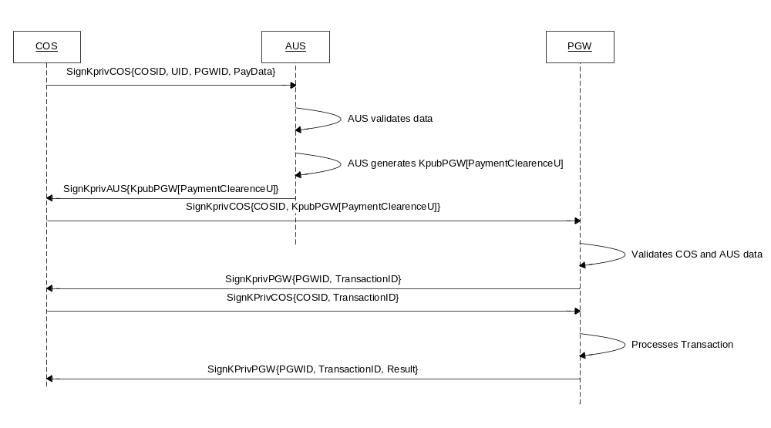
Figure 9 - Payment process

License Production
One of the major functionalities of the OpenSDoRM platform resides on the fact that it can control the way the Users access and use the content protected by the platform. This process is ensured by the production of licenses. These are later applied on the content of the user on the client player by the appropriate set of IPMP tools. These licenses are produced and stored securely by the LIS, according to the choices made by the User and after the payment has been performed. The process can be described in the following steps:
- The User selects a set of available conditions, that allow him to define the usage conditions (rights) of the content the User wants to access;
- COS sends a message to the LIS, requesting the production of a new license, for a specific content, and for a given User: SignKpriv_{COS}{U_{ID}, Content_{ID}, LicenseConditions, Cert_{AUS}^{COS}};
- LIS receives the request, verifies it and validates it. LIS generated the license using the appropriate language and parameters, contacting after the AUS for ciphering the license data for the User: SignKpriv_{LIS}{License};
- AUS receives the data, retrieves the Kpub_{User} and ciphers the received data: Kpub_{U}[License], returning it afterwards to the LIS: SignKpriv_{AUS}{Kpub_{User}[License]};
- LIS stores Kpub_{User}[License];

License Download
When the User tries to access the content on the client side the player verifies that a license is needed to access the content. The player contacts the wallet to try to obtain the required licenses and corresponding keys to access the content. This process can be described in the following steps:
- The player contacts the wallet to obtain the license for the ContentID and UserID;
- The wallet checks on its secure repository if a license for that specific ContentID is already there. If that is true than this license is returned for the player in order for the content to be deciphered and accessed, controlled by a set of IPMP tools. If the wallet doesn’t contain the license, it will request it from the LIS: SignKpriv_{U}{Cert_{AUS}^{User}, Content_{ID}};
- LIS receives the data, validates it and retrieves the license from the database, passing it to the wallet: SignKpriv_{LIS}{Kpub_{User}[License], Cert_{AUS}^{LIS}};
- The wallet receives the data from the LIS, validates the message and deciphers the license that is passed to the player. Also the license is stored on the wallet secure repository for future accesses.
The downloaded license is kept in the LIS for later crash recovery in an event of failure and later expiration checks.

License Expiry
Depending on the rights specified, a license will eventually expire. Rights such as a play count or a validity period may restrict the access to content to a certain number of times or to a certain time frame. The state of the license is maintained within the digital wallet. Upon expiration, for example when a play count reaches zero, the wallet automatically checks at the LIS for a new license for that particular content. If there is no license available and the user wants to continue with the consumption of the content he has purchase a new License as described before. The LIS also applies an internal checking algorithm to manage the state of its licenses. Licenses that expired will be removed from the LIS.

Services Description
The following section specifies to a greater extent all the services made available by each component on the platform.

AUS – Authentication Service

Description
The Authentication Service (AUS) is responsible in the OpenSDoRM system for two major authentication operations:
- Authenticate the different OpenSDoRM components;
- Authenticate the users that use the different components.

Function List Overview
The following table resumes the list of functionalities that are provided by the AUS. Annexed to the final of this document there is a WSDL description of the service.

Function Name | Description
AUSrequestModifyUserSubscription | This function is used to modify the data used by a User to subscribe to the Autentication Service.
AUSrequestUserSubscription | This function is used to subscribe a new User on the Authentication Service.
AUSrequestAuthentication | This function is used to validate and authenticate a user.
AUSrequestDeleteUserSubscription | This function is used to un-subscribe/remove a user from the system.
AUSrequestComponentSubscription | This function is used to register a new component on the system. This action will make a component valid in the OpenSDoRM context.
AUSrequestUserInfo | This function is used to request public user information from the Authentication Service component.
AUSrequestUserPaymentInfo | This function is used to request payment information for a given user from the AUS.
AUSrequestListOfPGW | This function is used to get a list of valid OpenSDoRM billing components from AUS.
AUSrequestMutualValidation | This function is an ah-hoc one, specific to the implementation of OpenSDoRM in music-4you (MOSES IST project).
AUSrequestWalletVerification | This function is used to validate if a given user has or not a Wallet.

Function List Detailed

AUSrequestModifyUserSubscription
Input Parameters
identification | String | This is the unique identifier that is associated with the component that is requesting this function.
signature_algorithm_identifier | String | A string that identifies the signature algorithm that is used to sign the messages.
name | String | The name of the user.
address | String | The address of the user.
email_address | String | The email address of the user that is being registered.
authentication_type | String | This field identifies the type of authentication that is going to be used by the user. It can be: LOGINPASSWORD or PUBLICKEY.
uid | String | This is the unique identifier of the user.
username | String | This is the username choosen by the user.
password | String | This is the password choosen by the user.
arbitrary_data | String | This is some additional arbitrary data that can be registered with the user.
signature | String | This is the signature of the message, generated by the component requesting this message.
Output Parameters
result_message | String | This is the resulting message of the service. If the message starts by +OK the function succeeded, if it starts by –ERR something wrong has occurred.

AUSrequestUserSubscription
Input Parameters
identification | String | This is the unique identifier that is associated with the component that is requesting this function.
signature_algorithm_identifier | String | A string that identifies the signature algorithm that is used to sign the messages.
name | String | The name of the user that is being registered.
address | String | The address of the user that is being registered.
email_address | String | The email address of the user that is being registered.
authentication_type | String | This field identifies the type of authentication that is going to be used by the user. It can be: LOGINPASSWORD or PUBLICKEY.
uid | String | This is the unique identifier of the user.
username | String | This is a username choosen by the user that is registering.
password | String | This is a password choosen by the user that is registering.
arbitrary_data | String | This is some additional arbitrary data that can be registered with the user.
signature | String | This is the signature of the message, generated by the component requesting this message.
Output Parameters
result_message | String | This is the resulting message of the service. If the message starts by +OK the function succeeded, if it starts by –ERR something wrong has occurred.
user_id | String | The user_id that the system has generated for this user

AUSrequestAuthentication
Input Parameters
identification | String | This is the unique identifier that is associated with the component that is requesting this function.
signature_algorithm_identifier | String | A string that identifies the signature algorithm that is used to sign the messages.
authentication_type | String | This field identifies the type of authentication that is going to be used by the user. It can be: LOGINPASSWORD or PUBLICKEY.
username | String | This is the username choosen by the user.
password | String | This is the password choosen by the user.
signature | String | This is the signature of the message, generated by the component requesting this message.
Output Parameters
result_message | String | This is the resulting message of the service. If the message starts by +OK the function succeeded, if it starts by –ERR something wrong has occurred.
user_id | String | The user_id that the system has associated with this user

AUSrequestDeleteUserSubscription
Input Parameters
identification | String | This is the unique identifier that is associated with the component that is requesting this function.
signature_algorithm_identifier | String | A string that identifies the signature algorithm that is used to sign the messages.
uid | String | This is the unique identifier of the user.
username | String | This is a username choosen by the user.
password | String | This is a password choosen by the user.
arbitrary_data | String | This is some additional arbitrary data.
signature | String | This is the signature of the message, generated by the component requesting this message.
Output Parameters
result_message | String | This is the resulting message of the service. If the message starts by +OK the function succeeded, if it starts by –ERR something wrong has occurred.

AUSrequestComponentSubscription
Input Parameters
public_key | String | This is the public key of the component, needed to register the component in the system.
password | String | This is a password choosen by the administrator that is registering the new component.
arbitrary_data | String | This is some additional arbitrary data that can be registered with the component.
Output Parameters
result_message | String | This is the resulting message of the service. If the message starts by +OK the function succeeded, if it starts by –ERR something wrong has occurred.
certificate | String | Certificate of the component freshly generated by the Authentication Service.

AUSrequestUserInfo
Input Parameters
identification | String | This is the unique identifier that is associated with the component that is requesting this function.
signature_algorithm_identifier | String | A string that identifies the signature algorithm that is used to sign the messages.
authentication_type | String | This field identifies the type of authentication that is going to be used by the user. It can be: LOGINPASSWORD or PUBLICKEY.
uid | String | This is the unique identifier of the user.
username | String | This is a username choosen by the user.
password | String | This is a password choosen by the user.
signature | String | This is the signature of the message, generated by the component requesting this message.
Output Parameters
result_message | String | This is the resulting message of the service. If the message starts by +OK the function succeeded, if it starts by –ERR something wrong has occurred.
name | String | Information about the user.
address | String | Information about the user.
email_address | String | Information about the user.
uid | String | This is the unique identifier of the user.
other_data | String | This is some additional arbitrary data that could have been registered with the user.
certificate | String | Certificate of the user, generated by the system at registration time.

AUSrequestUserPaymentInfo
Input Parameters
identification | String | This is the unique identifier that is associated with the component that is requesting this function.
signature_algorithm_identifier | String | A string that identifies the signature algorithm that is used to sign the messages.
pgw_identification | String | Identification of the PGW that will process the payment, in order to allow only this PGW to access the payment information (public key encryption).
user_identification | String | The user that started the transaction.
pvalue | String | The value of the transaction.
signature | String | This is the signature of the message, generated by the component requesting this message.
Output Parameters
result_message | String | This is the resulting message of the service. If the message starts by +OK the function succeeded, if it starts by –ERR something wrong has occurred.
payclearer | String | Data to be sent to the PGW.

AUSrequestListOfPGW
Input Parameters
identification | String | This is the unique identifier that is associated with the component that is requesting this function.
signature_algorithm_identifier | String | A string that identifies the signature algorithm that is used to sign the messages.
authentication_type | String | This field identifies the type of authentication that is going to be used by the user. It can be: LOGINPASSWORD or PUBLICKEY.
signature | String | This is the signature of the message, generated by the component requesting this message.
Output Parameters
result_message | String | This is the resulting message of the service. If the message starts by +OK the function succeeded, if it starts by –ERR something wrong has occurred.
list_of_pgw | String | A list of PGW services available on the system.

AUSrequestMutualValidation
Input Parameters
uid | String | This is the unique system identifier of the user.
login | String | This is the user’s human readable login.
hash | String | HASH of the user’s username and password.
Output Parameters
result_message | String | This is the resulting message of the service. If the message starts by +OK the function succeeded, if it starts by –ERR something wrong has occurred.

AUSrequestWalletVerification
Input Parameters
uid | String | This is the unique identifier of the user.
Output Parameters
result_message | String | This is the resulting message of the service. If the message starts by +OK the function succeeded, if it starts by –ERR something wrong has occurred.

Examples

CFS – Configuration Service

Description
The CFS is responsible for keeping centralized configuration and setup data, essential to the correct functioning of the system as a whole.

Function List Overview
The following table resumes the list of functionalities that are provided by the CFS. Annexed to the final of this document there is a WSDL description of the service.

Function Name | Description
CFSrequestServerLocation | This function is used for a component to know the location of any other component that is part of the OpenSDoRM system.
CFSrequestLocationStorage | This function is used to request a new server storage location. This is used to add a new OpenSDoRM server on a central point where all the other services can contact.
CFSrequestLocationDelete | This function is used to remove a component location from the service.

Function List Detailed
CFSrequestServerLocation
Input Parameters
id | String | This is the unique identifier of the component that is being searched.
Output Parameters
result_message | String | This is the resulting message of the service. If the message starts by +OK the function succeeded, if it starts by –ERR something wrong has occurred.
location | String | The URL of the component.

CFSrequestLocationStorage
Input Parameters
id | String | This is the unique identifier of the component that is being added to the system.
location | String | The URL of the component.
Output Parameters
result_message | String | This is the resulting message of the service. If the message starts by +OK the function succeeded, if it starts by –ERR something wrong has occurred.

CFSrequestLocationDelete
Input Parameters
id | String | This is the unique identifier of the component that is being deleted.
Output Parameters
result_message | String | This is the resulting message of the service. If the message starts by +OK the function succeeded, if it starts by –ERR something wrong has occurred.

Examples

ITS – Protection Tools Service

Description
The ITS is responsible for managing the usage of protection tools throughout the system, from content producer to the end user.

Function List Overview
The following table resumes the list of functionalities that are provided by the ITS. Annexed to the final of this document there is a WSDL description of the service.

Function Name | Description
ITSrequestIPMPToolsList | This function is used to request a list of protection tools from the ITS.
ITSrequestIPMPToolDownload | This function is used to get the download location of a given protection tool.
ITSaddNewIPMPTool | This function is used to add a new protection tool to the ITS.
ITSrequestIPMPToolDetails | This function is used to get the details about a specific protection tool.

Function List Detailed
ITSrequestIPMPToolsList
Input Parameters
- | - | -
Output Parameters
result_message | String | This is the resulting message of the service. If the message starts by +OK the function succeeded, if it starts by –ERR something wrong has occurred.
ipmp_tools_list | String | A list containg the IPMP tools available.

ITSrequestIPMPToolDownload
Input Parameters
ipmp_tool_id | String | The unique identifier of the tool.
Output Parameters
result_message | String | This is the resulting message of the service. If the message starts by +OK the function succeeded, if it starts by –ERR something wrong has occurred.
ipmp_tool_url | String | The location URL of the tool, for download.

ITSaddNewIPMPTool
Input Parameters
ipmptoolid | String | This is the unique identifier of the IPMP tool.
ipmptoolurl | String | The location of the tool.
ipmptooldesc | String | A textual description of the tool.
Output Parameters
result_message | String | This is the resulting message of the service. If the message starts by +OK the function succeeded, if it starts by –ERR something wrong has occurred.

ITSrequestIPMPToolDetails
Input Parameters
ipmptoolid | String | This is the unique identifier of the tool.
Output Parameters
result_message | String | This is the resulting message of the service. If the message starts by +OK the function succeeded, if it starts by –ERR something wrong has occurred.
ipmptoolid | String | This is the unique identifier of the tool.
ipmptoolurl | String | The location of the tool.
ipmptooldesc | String | A textual description of the tool.

Examples

LIS – License Service

Description
This service is responsible for managing all the information related with the licenses on the OpenSDoRM system. This service is capable of handling the following functions:
- Storing the cryptographic keys which are associated with the content which is protected;
- Producing the licenses according to a set of conditions established by the content provider and the final user, for a specific content and specific user;
- Support the license download for a given user and content identifier.
The service is independent of the type of Rights Expression Language (REL) that is used to express the rights on the license. OpenSDoRM uses a template-like system that supports several types of licenses.

Function List Overview
The following table resumes the list of functionalities that are provided by the LIS. Annexed to the final of this document there is a WSDL description of the service.

Function Name | Description
LISrequestContentKeyStore | This function is used to store content keys on the LIS. The server can store one or more keys on the service for a given content.
LISrequestLicenseList | This function is used to list licenses from the LIS, that is according to a given criteria.
LISrequestLicenseDownload | This function is used to request the download of a license that was created previously on the system.
LISrequestLicenseDownloadSpecial | This function is used to request a license from the server.
LISrequestLicenseDelete | This function is requested to delete licenses from the license system.
LISrequestLicenseCreation | This function is used to request the creation of a license on the system.
LISrequestLicenseUpdate | This function is used to update the license parameters of a license that is already present on the system.
LISrequestLicensePassing | This function is used to pass licenses between users.

Function List Detailed
The following tables detail each of the functions which were identified previously on the previous table.

LISrequestContentKeyStore
Input Parameters
key | String | This is the content key, or list of keys that were used to protect the content
cid | String | This is the unique identifier of the content
Output Parameters
result_message | String | This is the resulting message of the service. If the message starts by +OK the function succeeded, if it starts by –ERR something wrong has occurred.

LISrequestLicenseList
Input Parameters
uid | String | This is the unique identifier of the user that is requesting to list the licenses.
cid | String | This is the unique identifier of the content
Output Parameters
result_message | String | This is the resulting message of the service. If the message starts by +OK the function succeeded, if it starts by –ERR something wrong has occurred.
list_of_licenses | String | This is a XML formatted message that contains all the licenses that a specific user (uid) has for a given content (cid).

LISrequestLicenseDownload
Input Parameters
uid | String | This is the unique identifier of the user that is requesting the operation.
cid | String | This is the unique identifier of the content
authData | String | This field contains an XML formatted message containing data that is used to authenticate the user.
Output Parameters
result_message | String | This is the resulting message of the service. If the message starts by +OK the function succeeded, if it starts by –ERR something wrong has occurred.
license | String | This is a XML formatted message that contains the requested license.

LISrequestLicenseDownloadSpecial
Input Parameters
uid | String | This is the unique identifier of the user that is requesting the operation.
cid | String | This is the unique identifier of the content.
authData | String | This field contains an XML formatted message containing data that is used to authenticate the user.
Output Parameters
result_message | String | This is the resulting message of the service. If the message starts by +OK the function succeeded, if it starts by –ERR something wrong has occurred.
license | String | This is a XML formatted message that contains the requested license.

LISrequestLicenseDelete
Input Parameters
uid | String | This is the unique identifier of the user that is requesting the operation.
cid | String | This is the unique identifier of the content.
Output Parameters
result_message | String | This is the resulting message of the service. If the message starts by +OK the function succeeded, if it starts by –ERR something wrong has occurred.

LISrequestLicenseCreation
Input Parameters
uid | String | This is the unique identifier of the user that is requesting the operation.
cid | String | This is the unique identifier of the content.
licdata | String | This is a formatted message containing data that composes the license
Output Parameters
result_message | String | This is the resulting message of the service. If the message starts by +OK the function succeeded, if it starts by –ERR something wrong has occurred.

LISrequestLicenseUpdate
Input Parameters
uid | String | This is the unique identifier of the user that is requesting the operation.
cid | String | This is the unique identifier of the content.
licdata | String | This field a formatted message containing data that composes the license
Output Parameters
result_message | String | This is the resulting message of the service. If the message starts by +OK the function succeeded, if it starts by –ERR something wrong has occurred.

LISrequestLicensePassing
Input Parameters
uid_source | String | The unique identifier of the user that wants to pass the license
uid_target | String | The unique identifier of the user that will receive the license
cid | String | The unique identifier of the content
rights | String | A formatted message containing the rights associated with the license
Output Parameters
result_message | String | This is the resulting message of the service. If the message starts by +OK the function succeeded, if it starts by –ERR something wrong has occurred.

Examples

MDS - Media Delivery Service

Description
This service is responsible for “knowing” the whereabouts of any given content protected by the platform.

Function List Overview
The following table resumes the list of functionalities that are provided by the MDS. Annexed to the final of this document there is a WSDL description of the service.

Function Name | Description
MDSrequestContentStorage | This function is used to store a given content location (not the content itself) on the media delivery system.
MDSrequestContentDelivery | This function is used to notify the system that a specific content was requested by a given user.
MDSrequestContentDownload | This function is used to notify the system that a specific content was downloaded from the system.
MDSrequestContentDelete | This function is used to notify the system that a given content was deleted from the system.
MDSrequestDirectoryList | This function is used to list the available content.
MDSrequestUpdate | This function is used to update the details of the content on the system.

Function List Detailed
MDSrequestContentStorage
Input Parameters
cid | String | The unique identifier of the content.
filetype | String | The filetype of the content.
protocol | String | The protocol used to access the content’s location.
location | String | The content location URL.
Output Parameters
result_message | String | This is the resulting message of the service. If the message starts by +OK the function succeeded, if it starts by –ERR something wrong has occurred.

MDSrequestContentDelivery
Input Parameters
user_id | String | The unique identifier of the user that is requesting the operation.
content_id | String | This is the unique identifier of the content
Output Parameters
result_message | String | This is the resulting message of the service. If the message starts by +OK the function succeeded, if it starts by –ERR something wrong has occurred.

MDSrequestContentDownload
Input Parameters
user_id | String | The unique identifier of the user that is requesting the operation.
content_id | String | This is the unique identifier of the content
Output Parameters
result_message | String | This is the resulting message of the service. If the message starts by +OK the function succeeded, if it starts by –ERR something wrong has occurred.
url | String | URL of the content ready for downloading.

MDSrequestContentDelete
Input Parameters
content_id | String | This is the unique identifier of the content.
Output Parameters
result_message | String | This is the resulting message of the service. If the message starts by +OK the function succeeded, if it starts by –ERR something wrong has occurred.

MDSrequestDirectoryList
Input Parameters
Output Parameters
result_message | String | This is the resulting message of the service. If the message starts by +OK the function succeeded, if it starts by –ERR something wrong has occurred.
clist | String

MDSrequestUpdate
Input Parameters
cid | String | The unique identifier of the content.
filetype | String | The filetype of the content.
protocol | String | The protocol used to access the content’s location.
location |  | The content location URL.
Output Parameters
result_message | String | This is the resulting message of the service. If the message starts by +OK the function succeeded, if it starts by –ERR something wrong has occurred.

Examples

PGW - Billing Service

Description
This service handles all payment necessities of the system.

Function List Overview
The following table resumes the list of functionalities that are provided by the PGW. Annexed to the final of this document there is a WSDL description of the service.

Function Name | Description
PGWrequestPaymentClearence | This function is used to request a payment clearance from the billing system, clearing the payment instrument that was used by the user.
PGWrequestPaymentCapture | This function is used to capture the payment from a previously cleared transaction.
PGWrequestCOSSubscribe | This function is used for a new content store (or any other content selection module) to subscribe a billing system.

Function List Detailed
PGWrequestPaymentClearence
Input Parameters
identification | String | This is the unique identifier that is associated with the component that is requesting this function.
signature_algorithm_identifier | String | A string that identifies the signature algorithm that is used to sign the messages.
data | String | Data relevant to the payment operation.
signature | String | This is the signature of the message, generated by the component requesting this message.
Output Parameters
result_message | String | This is the resulting message of the service. If the message starts by +OK the function succeeded, if it starts by –ERR something wrong has occurred.
transaction_number | String | The transaction number.

PGWrequestPaymentCapture
Input Parameters
identification | String | This is the unique identifier that is associated with the component that is requesting this function.
signature_algorithm_identifier | String | A string that identifies the signature algorithm that is used to sign the messages.
tid | String | The transaction’s unique identifier
signature | String | This is the signature of the message, generated by the component requesting this message.
Output Parameters
result_message | String | This is the resulting message of the service. If the message starts by +OK the function succeeded, if it starts by –ERR something wrong has occurred.
transaction_number | String | The transaction number.

PGWrequestCOSSubscribe
Input Parameters
identification | String | This is the unique identifier that is associated with the component that is requesting this function.
signature_algorithm_identifier | String | A string that identifies the signature algorithm that is used to sign the messages.
certificate | String | The certificate of the COS.
signature | String | This is the signature of the message, generated by the component requesting this message.
Output Parameters
result_message | String | This is the resulting message of the service. If the message starts by +OK the function succeeded, if it starts by –ERR something wrong has occurred.
cert | String

Examples

RGS – Registration Service

Description
The Registration Service is responsible for assigning unique content identifiers and for registering specific metadata associated with a given content.

Function List Overview
The following table resumes the list of functionalities that are provided by the RGS. Annexed to the final of this document there is a WSDL description of the service.

Function Name | Description
RGSrequestContentRegistration | This function is used to register a new content on the system.
RGSrequestMetadataRegistration | This function is used to register metadata that is associated with a specific content.
RGSrequestListAvailableContent | This function is used to list the available content on the system that matches with specific criteria.
RGSrequestListMetadata | This function is used to list the available metadata associated with content on the system that matches with specific criteria.

Function List Detailed
RGSrequestContentRegistration
Input Parameters
identification | String | This is the unique identifier that is associated with the component that is requesting this function.
signature_algorithm_identifier | String | A string that identifies the signature algorithm that is used to sign the messages.
hash | String | The HASH value of the original content.
file | String | A preview file of the content.
additional_data | String | This is some additional data that can be registered with the user.
aus_cert | String | The AUS certificate of the requesting entity.
signature | String | This is the signature of the message, generated by the component requesting this message.
Output Parameters
status_message | String | This is the resulting message of the service. If the message starts by +OK the function succeeded, if it starts by –ERR something wrong has occurred.
content_id | String | The content’s unique identifier assigned by the RGS.

RGSrequestMetadataRegistration
Input Parameters
identification | String | This is the unique identifier that is associated with the component that is requesting this function.
signature_algorithm_identifier | String | A string that identifies the signature algorithm that is used to sign the messages.
content_id | String | The unique identifier of the content.
metadata | String | Metadata associated with the content
aus_cert | String | The AUS certificate of the requesting entity.
signature | String | This is the signature of the message, generated by the component requesting this message.
Output Parameters
status_message | String | This is the resulting message of the service. If the message starts by +OK the function succeeded, if it starts by –ERR something wrong has occurred.

RGSrequestListAvailableContent
Input Parameters
identification | String | This is the unique identifier that is associated with the component that is requesting this function.
signature_algorithm_identifier | String | A string that identifies the signature algorithm that is used to sign the messages.
criteria | String | SQL formatted query to access available content.
aus_cert | String | The AUS certificate of the requesting entity.
signature | String | This is the signature of the message, generated by the component requesting this message.
Output Parameters
status_message | String | This is the resulting message of the service. If the message starts by +OK the function succeeded, if it starts by –ERR something wrong has occurred.
content | String | An XML formatted message with the content’s details.

RGSrequestListMetadata
Input Parameters
identification | String | This is the unique identifier that is associated with the component that is requesting this function.
signature_algorithm_identifier | String | A string that identifies the signature algorithm that is used to sign the messages.
criteria | String | SQL formatted query to access available metadata.
aus_cert | String | The AUS certificate of the requesting entity.
signature | String | This is the signature of the message, generated by the component requesting this message.
Output Parameters
status_message | String | This is the resulting message of the service. If the message starts by +OK the function succeeded, if it starts by –ERR something wrong has occurred.
content_id | String | The content’s unique identifier
metadata |  | The metadata associated with the content.

Examples

Annex – WSDL descriptions of all the services

AUS – Authentication Service
WSDL location: | D:\WWW\opensdrm\wsdl\ausws.wsdl
targetnamespace: | http://www.adetti.pt/opensdrmws

services | bindings | porttypes | messages
opensdrmws | opensdrmwsBinding | opensdrmwsPortType | AUSrequestAuthenticationRequest
 |  |  | AUSrequestAuthenticationResponse
 |  |  | AUSrequestComponentSubscriptionRequest
 |  |  | AUSrequestComponentSubscriptionResponse
 |  |  | AUSrequestDeleteUserSubscriptionRequest
 |  |  | AUSrequestDeleteUserSubscriptionResponse
 |  |  | AUSrequestListOfPGWRequest
 |  |  | AUSrequestListOfPGWResponse
 |  |  | AUSrequestModifyUserSubscriptionRequest
 |  |  | AUSrequestModifyUserSubscriptionResponse
 |  |  | AUSrequestMutualValidationRequest
 |  |  | AUSrequestMutualValidationResponse
 |  |  | AUSrequestUserInfoRequest
 |  |  | AUSrequestUserInfoResponse
 |  |  | AUSrequestUserPaymentInfoRequest
 |  |  | AUSrequestUserPaymentInfoResponse
 |  |  | AUSrequestUserSubscriptionRequest
 |  |  | AUSrequestUserSubscriptionResponse
 |  |  | AUSrequestWalletVerificationRequest
 |  |  | AUSrequestWalletVerificationResponse

service opensdrmws
ports
  opensdrmwsPort
  binding | tns:opensdrmwsBinding
  extensibility | <soap:address location="http://localhost/opensdrm/AUS/AUS.ws.php"/>
source | <service name="opensdrmws">  <port name="opensdrmwsPort" binding="tns:opensdrmwsBinding">  <soap:address location="http://localhost/opensdrm/AUS/AUS.ws.php"/>  </port>  </service>

binding opensdrmwsBinding
type | tns:opensdrmwsPortType
extensibility | <soap:binding style="rpc" transport="http://schemas.xmlsoap.org/soap/http"/>
operations
  AUSrequestModifyUserSubscription
  extensibility | <soap:operation soapAction="http://localhost/opensdrm/AUS/AUS.ws.php/AUSrequestModifyUserSubscription" style="rpc"/>
  input | <soap:body use="encoded" encodingStyle="http://schemas.xmlsoap.org/soap/encoding/" namespace="http://www.adetti.pt/opensdrmws"/>
  output | <soap:body use="encoded" encodingStyle="http://schemas.xmlsoap.org/soap/encoding/" namespace="http://www.adetti.pt/opensdrmws"/>
  AUSrequestUserSubscription
  extensibility | <soap:operation soapAction="http://localhost/opensdrm/AUS/AUS.ws.php/AUSrequestUserSubscription" style="rpc"/>
  input | <soap:body use="encoded" encodingStyle="http://schemas.xmlsoap.org/soap/encoding/" namespace="http://www.adetti.pt/opensdrmws"/>
  output | <soap:body use="encoded" encodingStyle="http://schemas.xmlsoap.org/soap/encoding/" namespace="http://www.adetti.pt/opensdrmws"/>
  AUSrequestAuthentication
  extensibility | <soap:operation soapAction="http://localhost/opensdrm/AUS/AUS.ws.php/AUSrequestAuthentication" style="rpc"/>
  input | <soap:body use="encoded" encodingStyle="http://schemas.xmlsoap.org/soap/encoding/" namespace="http://www.adetti.pt/opensdrmws"/>
  output | <soap:body use="encoded" encodingStyle="http://schemas.xmlsoap.org/soap/encoding/" namespace="http://www.adetti.pt/opensdrmws"/>
  AUSrequestDeleteUserSubscription
  extensibility | <soap:operation soapAction="http://localhost/opensdrm/AUS/AUS.ws.php/AUSrequestDeleteUserSubscription" style="rpc"/>
  input | <soap:body use="encoded" encodingStyle="http://schemas.xmlsoap.org/soap/encoding/" namespace="http://www.adetti.pt/opensdrmws"/>
  output | <soap:body use="encoded" encodingStyle="http://schemas.xmlsoap.org/soap/encoding/" namespace="http://www.adetti.pt/opensdrmws"/>
  AUSrequestComponentSubscription
  extensibility | <soap:operation soapAction="http://localhost/opensdrm/AUS/AUS.ws.php/AUSrequestComponentSubscription" style="rpc"/>
  input | <soap:body use="encoded" encodingStyle="http://schemas.xmlsoap.org/soap/encoding/" namespace="http://www.adetti.pt/opensdrmws"/>
  output | <soap:body use="encoded" encodingStyle="http://schemas.xmlsoap.org/soap/encoding/" namespace="http://www.adetti.pt/opensdrmws"/>
  AUSrequestUserInfo
  extensibility | <soap:operation soapAction="http://localhost/opensdrm/AUS/AUS.ws.php/AUSrequestUserInfo" style="rpc"/>
  input | <soap:body use="encoded" encodingStyle="http://schemas.xmlsoap.org/soap/encoding/" namespace="http://www.adetti.pt/opensdrmws"/>
  output | <soap:body use="encoded" encodingStyle="http://schemas.xmlsoap.org/soap/encoding/" namespace="http://www.adetti.pt/opensdrmws"/>
  AUSrequestUserPaymentInfo
  extensibility | <soap:operation soapAction="http://localhost/opensdrm/AUS/AUS.ws.php/AUSrequestUserPaymentInfo" style="rpc"/>
  input | <soap:body use="encoded" encodingStyle="http://schemas.xmlsoap.org/soap/encoding/" namespace="http://www.adetti.pt/opensdrmws"/>
  output | <soap:body use="encoded" encodingStyle="http://schemas.xmlsoap.org/soap/encoding/" namespace="http://www.adetti.pt/opensdrmws"/>
  AUSrequestListOfPGW
  extensibility | <soap:operation soapAction="http://localhost/opensdrm/AUS/AUS.ws.php/AUSrequestListOfPGW" style="rpc"/>
  input | <soap:body use="encoded" encodingStyle="http://schemas.xmlsoap.org/soap/encoding/" namespace="http://www.adetti.pt/opensdrmws"/>
  output | <soap:body use="encoded" encodingStyle="http://schemas.xmlsoap.org/soap/encoding/" namespace="http://www.adetti.pt/opensdrmws"/>
  AUSrequestMutualValidation
  extensibility | <soap:operation soapAction="http://localhost/opensdrm/AUS/AUS.ws.php/AUSrequestMutualValidation" style="rpc"/>
  input | <soap:body use="encoded" encodingStyle="http://schemas.xmlsoap.org/soap/encoding/" namespace="http://www.adetti.pt/opensdrmws"/>
  output | <soap:body use="encoded" encodingStyle="http://schemas.xmlsoap.org/soap/encoding/" namespace="http://www.adetti.pt/opensdrmws"/>
  AUSrequestWalletVerification
  extensibility | <soap:operation soapAction="http://localhost/opensdrm/AUS/AUS.ws.php/AUSrequestWalletVerification" style="rpc"/>
  input | <soap:body use="encoded" encodingStyle="http://schemas.xmlsoap.org/soap/encoding/" namespace="http://www.adetti.pt/opensdrmws"/>
  output | <soap:body use="encoded" encodingStyle="http://schemas.xmlsoap.org/soap/encoding/" namespace="http://www.adetti.pt/opensdrmws"/>
used by
  Service opensdrmws in Port opensdrmwsPort
source | <binding name="opensdrmwsBinding" type="tns:opensdrmwsPortType">  <soap:binding style="rpc" transport="http://schemas.xmlsoap.org/soap/http"/>  <operation name="AUSrequestModifyUserSubscription">  <soap:operation soapAction="http://localhost/opensdrm/AUS/AUS.ws.php/AUSrequestModifyUserSubscription" style="rpc"/>  <input>  <soap:body use="encoded" encodingStyle="http://schemas.xmlsoap.org/soap/encoding/" namespace="http://www.adetti.pt/opensdrmws"/>  </input>  <output>  <soap:body use="encoded" encodingStyle="http://schemas.xmlsoap.org/soap/encoding/" namespace="http://www.adetti.pt/opensdrmws"/>  </output>  </operation>  <operation name="AUSrequestUserSubscription">  <soap:operation soapAction="http://localhost/opensdrm/AUS/AUS.ws.php/AUSrequestUserSubscription" style="rpc"/>  <input>  <soap:body use="encoded" encodingStyle="http://schemas.xmlsoap.org/soap/encoding/" namespace="http://www.adetti.pt/opensdrmws"/>  </input>  <output>  <soap:body use="encoded" encodingStyle="http://schemas.xmlsoap.org/soap/encoding/" namespace="http://www.adetti.pt/opensdrmws"/>  </output>  </operation>  <operation name="AUSrequestAuthentication">  <soap:operation soapAction="http://localhost/opensdrm/AUS/AUS.ws.php/AUSrequestAuthentication" style="rpc"/>  <input>  <soap:body use="encoded" encodingStyle="http://schemas.xmlsoap.org/soap/encoding/" namespace="http://www.adetti.pt/opensdrmws"/>  </input>  <output>  <soap:body use="encoded" encodingStyle="http://schemas.xmlsoap.org/soap/encoding/" namespace="http://www.adetti.pt/opensdrmws"/>  </output>  </operation>  <operation name="AUSrequestDeleteUserSubscription">  <soap:operation soapAction="http://localhost/opensdrm/AUS/AUS.ws.php/AUSrequestDeleteUserSubscription" style="rpc"/>  <input>  <soap:body use="encoded" encodingStyle="http://schemas.xmlsoap.org/soap/encoding/" namespace="http://www.adetti.pt/opensdrmws"/>  </input>  <output>  <soap:body use="encoded" encodingStyle="http://schemas.xmlsoap.org/soap/encoding/" namespace="http://www.adetti.pt/opensdrmws"/>  </output>  </operation>  <operation name="AUSrequestComponentSubscription">  <soap:operation soapAction="http://localhost/opensdrm/AUS/AUS.ws.php/AUSrequestComponentSubscription" style="rpc"/>  <input>  <soap:body use="encoded" encodingStyle="http://schemas.xmlsoap.org/soap/encoding/" namespace="http://www.adetti.pt/opensdrmws"/>  </input>  <output>  <soap:body use="encoded" encodingStyle="http://schemas.xmlsoap.org/soap/encoding/" namespace="http://www.adetti.pt/opensdrmws"/>  </output>  </operation>  <operation name="AUSrequestUserInfo">  <soap:operation soapAction="http://localhost/opensdrm/AUS/AUS.ws.php/AUSrequestUserInfo" style="rpc"/>  <input>  <soap:body use="encoded" encodingStyle="http://schemas.xmlsoap.org/soap/encoding/" namespace="http://www.adetti.pt/opensdrmws"/>  </input>  <output>  <soap:body use="encoded" encodingStyle="http://schemas.xmlsoap.org/soap/encoding/" namespace="http://www.adetti.pt/opensdrmws"/>  </output>  </operation>  <operation name="AUSrequestUserPaymentInfo">  <soap:operation soapAction="http://localhost/opensdrm/AUS/AUS.ws.php/AUSrequestUserPaymentInfo" style="rpc"/>  <input>  <soap:body use="encoded" encodingStyle="http://schemas.xmlsoap.org/soap/encoding/" namespace="http://www.adetti.pt/opensdrmws"/>  </input>  <output>  <soap:body use="encoded" encodingStyle="http://schemas.xmlsoap.org/soap/encoding/" namespace="http://www.adetti.pt/opensdrmws"/>  </output>  </operation>  <operation name="AUSrequestListOfPGW">  <soap:operation soapAction="http://localhost/opensdrm/AUS/AUS.ws.php/AUSrequestListOfPGW" style="rpc"/>  <input>  <soap:body use="encoded" encodingStyle="http://schemas.xmlsoap.org/soap/encoding/" namespace="http://www.adetti.pt/opensdrmws"/>  </input>  <output>  <soap:body use="encoded" encodingStyle="http://schemas.xmlsoap.org/soap/encoding/" namespace="http://www.adetti.pt/opensdrmws"/>  </output>  </operation>  <operation name="AUSrequestMutualValidation">  <soap:operation soapAction="http://localhost/opensdrm/AUS/AUS.ws.php/AUSrequestMutualValidation" style="rpc"/>  <input>  <soap:body use="encoded" encodingStyle="http://schemas.xmlsoap.org/soap/encoding/" namespace="http://www.adetti.pt/opensdrmws"/>  </input>  <output>  <soap:body use="encoded" encodingStyle="http://schemas.xmlsoap.org/soap/encoding/" namespace="http://www.adetti.pt/opensdrmws"/>  </output>  </operation>  <operation name="AUSrequestWalletVerification">  <soap:operation soapAction="http://localhost/opensdrm/AUS/AUS.ws.php/AUSrequestWalletVerification" style="rpc"/>  <input>  <soap:body use="encoded" encodingStyle="http://schemas.xmlsoap.org/soap/encoding/" namespace="http://www.adetti.pt/opensdrmws"/>  </input>  <output>  <soap:body use="encoded" encodingStyle="http://schemas.xmlsoap.org/soap/encoding/" namespace="http://www.adetti.pt/opensdrmws"/>  </output>  </operation>  </binding>

porttype opensdrmwsPortType
operations
  AUSrequestModifyUserSubscription
  input | tns:AUSrequestModifyUserSubscriptionRequest
  output | tns:AUSrequestModifyUserSubscriptionResponse
  AUSrequestUserSubscription
  input | tns:AUSrequestUserSubscriptionRequest
  output | tns:AUSrequestUserSubscriptionResponse
  AUSrequestAuthentication
  input | tns:AUSrequestAuthenticationRequest
  output | tns:AUSrequestAuthenticationResponse
  AUSrequestDeleteUserSubscription
  input | tns:AUSrequestDeleteUserSubscriptionRequest
  output | tns:AUSrequestDeleteUserSubscriptionResponse
  AUSrequestComponentSubscription
  input | tns:AUSrequestComponentSubscriptionRequest
  output | tns:AUSrequestComponentSubscriptionResponse
  AUSrequestUserInfo
  input | tns:AUSrequestUserInfoRequest
  output | tns:AUSrequestUserInfoResponse
  AUSrequestUserPaymentInfo
  input | tns:AUSrequestUserPaymentInfoRequest
  output | tns:AUSrequestUserPaymentInfoResponse
  AUSrequestListOfPGW
  input | tns:AUSrequestListOfPGWRequest
  output | tns:AUSrequestListOfPGWResponse
  AUSrequestMutualValidation
  input | tns:AUSrequestMutualValidationRequest
  output | tns:AUSrequestMutualValidationResponse
  AUSrequestWalletVerification
  input | tns:AUSrequestWalletVerificationRequest
  output | tns:AUSrequestWalletVerificationResponse
used by
  binding opensdrmwsBinding
source | <portType name="opensdrmwsPortType">  <operation name="AUSrequestModifyUserSubscription">  <input message="tns:AUSrequestModifyUserSubscriptionRequest"/>  <output message="tns:AUSrequestModifyUserSubscriptionResponse"/>  </operation>  <operation name="AUSrequestUserSubscription">  <input message="tns:AUSrequestUserSubscriptionRequest"/>  <output message="tns:AUSrequestUserSubscriptionResponse"/>  </operation>  <operation name="AUSrequestAuthentication">  <input message="tns:AUSrequestAuthenticationRequest"/>  <output message="tns:AUSrequestAuthenticationResponse"/>  </operation>  <operation name="AUSrequestDeleteUserSubscription">  <input message="tns:AUSrequestDeleteUserSubscriptionRequest"/>  <output message="tns:AUSrequestDeleteUserSubscriptionResponse"/>  </operation>  <operation name="AUSrequestComponentSubscription">  <input message="tns:AUSrequestComponentSubscriptionRequest"/>  <output message="tns:AUSrequestComponentSubscriptionResponse"/>  </operation>  <operation name="AUSrequestUserInfo">  <input message="tns:AUSrequestUserInfoRequest"/>  <output message="tns:AUSrequestUserInfoResponse"/>  </operation>  <operation name="AUSrequestUserPaymentInfo">  <input message="tns:AUSrequestUserPaymentInfoRequest"/>  <output message="tns:AUSrequestUserPaymentInfoResponse"/>  </operation>  <operation name="AUSrequestListOfPGW">  <input message="tns:AUSrequestListOfPGWRequest"/>  <output message="tns:AUSrequestListOfPGWResponse"/>  </operation>  <operation name="AUSrequestMutualValidation">  <input message="tns:AUSrequestMutualValidationRequest"/>  <output message="tns:AUSrequestMutualValidationResponse"/>  </operation>  <operation name="AUSrequestWalletVerification">  <input message="tns:AUSrequestWalletVerificationRequest"/>  <output message="tns:AUSrequestWalletVerificationResponse"/>  </operation>  </portType>

message AUSrequestModifyUserSubscriptionRequest
parts
  identification
  type | xsd:string
  signature_algorithm_identifier
  type | xsd:string
  name
  type | xsd:string
  address
  type | xsd:string
  email_address
  type | xsd:string
  authentication_type
  type | xsd:string
  uid
  type | xsd:string
  username
  type | xsd:string
  password
  type | xsd:string
  arbitrary_data
  type | xsd:string
  signature
  type | xsd:string
used by
  PortType opensdrmwsPortType in Operation AUSrequestModifyUserSubscription
source | <message name="AUSrequestModifyUserSubscriptionRequest">  <part name="identification" type="xsd:string"/>  <part name="signature_algorithm_identifier" type="xsd:string"/>  <part name="name" type="xsd:string"/>  <part name="address" type="xsd:string"/>  <part name="email_address" type="xsd:string"/>  <part name="authentication_type" type="xsd:string"/>  <part name="uid" type="xsd:string"/>  <part name="username" type="xsd:string"/>  <part name="password" type="xsd:string"/>  <part name="arbitrary_data" type="xsd:string"/>  <part name="signature" type="xsd:string"/>  </message>

message AUSrequestModifyUserSubscriptionResponse
parts
  result_message
  type | xsd:string
used by
  PortType opensdrmwsPortType in Operation AUSrequestModifyUserSubscription
source | <message name="AUSrequestModifyUserSubscriptionResponse">  <part name="result_message" type="xsd:string"/>  </message>

message AUSrequestUserSubscriptionRequest
parts
  identification
  type | xsd:string
  signature_algorithm_identifier
  type | xsd:string
  name
  type | xsd:string
  address
  type | xsd:string
  email_address
  type | xsd:string
  authentication_type
  type | xsd:string
  username
  type | xsd:string
  password
  type | xsd:string
  public_key
  type | xsd:string
  arbitrary_data
  type | xsd:string
  signature
  type | xsd:string
used by
  PortType opensdrmwsPortType in Operation AUSrequestUserSubscription
source | <message name="AUSrequestUserSubscriptionRequest">  <part name="identification" type="xsd:string"/>  <part name="signature_algorithm_identifier" type="xsd:string"/>  <part name="name" type="xsd:string"/>  <part name="address" type="xsd:string"/>  <part name="email_address" type="xsd:string"/>  <part name="authentication_type" type="xsd:string"/>  <part name="username" type="xsd:string"/>  <part name="password" type="xsd:string"/>  <part name="public_key" type="xsd:string"/>  <part name="arbitrary_data" type="xsd:string"/>  <part name="signature" type="xsd:string"/>  </message>

message AUSrequestUserSubscriptionResponse
parts
  result_message
  type | xsd:string
  user_id
  type | xsd:string
used by
  PortType opensdrmwsPortType in Operation AUSrequestUserSubscription
source | <message name="AUSrequestUserSubscriptionResponse">  <part name="result_message" type="xsd:string"/>  <part name="user_id" type="xsd:string"/>  </message>

message AUSrequestAuthenticationRequest
parts
  identification
  type | xsd:string
  signature_algorithm_identifier
  type | xsd:string
  authentication_type
  type | xsd:string
  username
  type | xsd:string
  password
  type | xsd:string
  signature
  type | xsd:string
used by
  PortType opensdrmwsPortType in Operation AUSrequestAuthentication
source | <message name="AUSrequestAuthenticationRequest">  <part name="identification" type="xsd:string"/>  <part name="signature_algorithm_identifier" type="xsd:string"/>  <part name="authentication_type" type="xsd:string"/>  <part name="username" type="xsd:string"/>  <part name="password" type="xsd:string"/>  <part name="signature" type="xsd:string"/>  </message>

message AUSrequestAuthenticationResponse
parts
  result_message
  type | xsd:string
  user_id
  type | xsd:string
used by
  PortType opensdrmwsPortType in Operation AUSrequestAuthentication
source | <message name="AUSrequestAuthenticationResponse">  <part name="result_message" type="xsd:string"/>  <part name="user_id" type="xsd:string"/>  </message>

message AUSrequestDeleteUserSubscriptionRequest
parts
  identification
  type | xsd:string
  signature_algorithm_identifier
  type | xsd:string
  uid
  type | xsd:string
  username
  type | xsd:string
  password
  type | xsd:string
  arbitrary_data
  type | xsd:string
  signature
  type | xsd:string
used by
  PortType opensdrmwsPortType in Operation AUSrequestDeleteUserSubscription
source | <message name="AUSrequestDeleteUserSubscriptionRequest">  <part name="identification" type="xsd:string"/>  <part name="signature_algorithm_identifier" type="xsd:string"/>  <part name="uid" type="xsd:string"/>  <part name="username" type="xsd:string"/>  <part name="password" type="xsd:string"/>  <part name="arbitrary_data" type="xsd:string"/>  <part name="signature" type="xsd:string"/>  </message>

message AUSrequestDeleteUserSubscriptionResponse
parts
  result_message
  type | xsd:string
used by
  PortType opensdrmwsPortType in Operation AUSrequestDeleteUserSubscription
source | <message name="AUSrequestDeleteUserSubscriptionResponse">  <part name="result_message" type="xsd:string"/>  </message>

message AUSrequestComponentSubscriptionRequest
parts
  arbitrary_data
  type | xsd:string
  public_key
  type | xsd:string
  password
  type | xsd:string
used by
  PortType opensdrmwsPortType in Operation AUSrequestComponentSubscription
source | <message name="AUSrequestComponentSubscriptionRequest">  <part name="arbitrary_data" type="xsd:string"/>  <part name="public_key" type="xsd:string"/>  <part name="password" type="xsd:string"/>  </message>

message AUSrequestComponentSubscriptionResponse
parts
  result_message
  type | xsd:string
  certificate
  type | xsd:string
used by
  PortType opensdrmwsPortType in Operation AUSrequestComponentSubscription
source | <message name="AUSrequestComponentSubscriptionResponse">  <part name="result_message" type="xsd:string"/>  <part name="certificate" type="xsd:string"/>  </message>

message AUSrequestUserInfoRequest
parts
  identification
  type | xsd:string
  signature_algorithm_identifier
  type | xsd:string
  authentication_type
  type | xsd:string
  uid
  type | xsd:string
  username
  type | xsd:string
  password
  type | xsd:string
  signature
  type | xsd:string
used by
  PortType opensdrmwsPortType in Operation AUSrequestUserInfo
source | <message name="AUSrequestUserInfoRequest">  <part name="identification" type="xsd:string"/>  <part name="signature_algorithm_identifier" type="xsd:string"/>  <part name="authentication_type" type="xsd:string"/>  <part name="uid" type="xsd:string"/>  <part name="username" type="xsd:string"/>  <part name="password" type="xsd:string"/>  <part name="signature" type="xsd:string"/>  </message>

message AUSrequestUserInfoResponse
parts
  result_message
  type | xsd:string
  uid
  type | xsd:string
  name
  type | xsd:string
  address
  type | xsd:string
  email
  type | xsd:string
  other_data_xml
  type | xsd:string
  certificate
  type | xsd:string
used by
  PortType opensdrmwsPortType in Operation AUSrequestUserInfo
source | <message name="AUSrequestUserInfoResponse">  <part name="result_message" type="xsd:string"/>  <part name="uid" type="xsd:string"/>  <part name="name" type="xsd:string"/>  <part name="address" type="xsd:string"/>  <part name="email" type="xsd:string"/>  <part name="other_data_xml" type="xsd:string"/>  <part name="certificate" type="xsd:string"/>  </message>

message AUSrequestUserPaymentInfoRequest
parts
  identification
  type | xsd:string
  signature_algorithm_identifier
  type | xsd:string
  pgw_identification
  type | xsd:string
  user_identification
  type | xsd:string
  pvalue
  type | xsd:string
  signature
  type | xsd:string
used by
  PortType opensdrmwsPortType in Operation AUSrequestUserPaymentInfo
source | <message name="AUSrequestUserPaymentInfoRequest">  <part name="identification" type="xsd:string"/>  <part name="signature_algorithm_identifier" type="xsd:string"/>  <part name="pgw_identification" type="xsd:string"/>  <part name="user_identification" type="xsd:string"/>  <part name="pvalue" type="xsd:string"/>  <part name="signature" type="xsd:string"/>  </message>

message AUSrequestUserPaymentInfoResponse
parts
  result_message
  type | xsd:string
  payclearer
  type | xsd:string
used by
  PortType opensdrmwsPortType in Operation AUSrequestUserPaymentInfo
source | <message name="AUSrequestUserPaymentInfoResponse">  <part name="result_message" type="xsd:string"/>  <part name="payclearer" type="xsd:string"/>  </message>

message AUSrequestListOfPGWRequest
parts
  identification
  type | xsd:string
  signature_algorithm_identifier
  type | xsd:string
  authentication_type
  type | xsd:string
  signature
  type | xsd:string
used by
  PortType opensdrmwsPortType in Operation AUSrequestListOfPGW
source | <message name="AUSrequestListOfPGWRequest">  <part name="identification" type="xsd:string"/>  <part name="signature_algorithm_identifier" type="xsd:string"/>  <part name="authentication_type" type="xsd:string"/>  <part name="signature" type="xsd:string"/>  </message>

message AUSrequestListOfPGWResponse
parts
  result_message
  type | xsd:string
  list_of_pgw
  type | xsd:string
used by
  PortType opensdrmwsPortType in Operation AUSrequestListOfPGW
source | <message name="AUSrequestListOfPGWResponse">  <part name="result_message" type="xsd:string"/>  <part name="list_of_pgw" type="xsd:string"/>  </message>

message AUSrequestMutualValidationRequest
parts
  uid
  type | xsd:string
  login
  type | xsd:string
  hash
  type | xsd:string
used by
  PortType opensdrmwsPortType in Operation AUSrequestMutualValidation
source | <message name="AUSrequestMutualValidationRequest">  <part name="uid" type="xsd:string"/>  <part name="login" type="xsd:string"/>  <part name="hash" type="xsd:string"/>  </message>

message AUSrequestMutualValidationResponse
parts
  result_message
  type | xsd:string
used by
  PortType opensdrmwsPortType in Operation AUSrequestMutualValidation
source | <message name="AUSrequestMutualValidationResponse">  <part name="result_message" type="xsd:string"/>  </message>

message AUSrequestWalletVerificationRequest
parts
  uid
  type | xsd:string
used by
  PortType opensdrmwsPortType in Operation AUSrequestWalletVerification
source | <message name="AUSrequestWalletVerificationRequest">  <part name="uid" type="xsd:string"/>  </message>

message AUSrequestWalletVerificationResponse
parts
  result_message
  type | xsd:string
used by
  PortType opensdrmwsPortType in Operation AUSrequestWalletVerification
source | <message name="AUSrequestWalletVerificationResponse">  <part name="result_message" type="xsd:string"/>  </message>

CFS – Configuration Service
WSDL location: | D:\WWW\opensdrm\wsdl\cfsws.wsdl
targetnamespace: | http://www.adetti.pt/opensdrmws

services | bindings | porttypes | messages
opensdrmws | opensdrmwsBinding | opensdrmwsPortType | CFSrequestLocationDeleteRequest
 |  |  | CFSrequestLocationDeleteResponse
 |  |  | CFSrequestLocationStorageRequest
 |  |  | CFSrequestLocationStorageResponse
 |  |  | CFSrequestServerLocationRequest
 |  |  | CFSrequestServerLocationResponse

service opensdrmws
ports
  opensdrmwsPort
  binding | tns:opensdrmwsBinding
  extensibility | <soap:address location="http://localhost/opensdrm/CFS/CFS.ws.php"/>
source | <service name="opensdrmws">  <port name="opensdrmwsPort" binding="tns:opensdrmwsBinding">  <soap:address location="http://localhost/opensdrm/CFS/CFS.ws.php"/>  </port>  </service>

binding opensdrmwsBinding
type | tns:opensdrmwsPortType
extensibility | <soap:binding style="rpc" transport="http://schemas.xmlsoap.org/soap/http"/>
operations
  CFSrequestServerLocation
  extensibility | <soap:operation soapAction="http://localhost/opensdrm/CFS/CFS.ws.php/CFSrequestServerLocation" style="rpc"/>
  input | <soap:body use="encoded" encodingStyle="http://schemas.xmlsoap.org/soap/encoding/" namespace="http://www.adetti.pt/opensdrmws"/>
  output | <soap:body use="encoded" encodingStyle="http://schemas.xmlsoap.org/soap/encoding/" namespace="http://www.adetti.pt/opensdrmws"/>
  CFSrequestLocationStorage
  extensibility | <soap:operation soapAction="http://localhost/opensdrm/CFS/CFS.ws.php/CFSrequestLocationStorage" style="rpc"/>
  input | <soap:body use="encoded" encodingStyle="http://schemas.xmlsoap.org/soap/encoding/" namespace="http://www.adetti.pt/opensdrmws"/>
  output | <soap:body use="encoded" encodingStyle="http://schemas.xmlsoap.org/soap/encoding/" namespace="http://www.adetti.pt/opensdrmws"/>
  CFSrequestLocationDelete
  extensibility | <soap:operation soapAction="http://localhost/opensdrm/CFS/CFS.ws.php/CFSrequestLocationDelete" style="rpc"/>
  input | <soap:body use="encoded" encodingStyle="http://schemas.xmlsoap.org/soap/encoding/" namespace="http://www.adetti.pt/opensdrmws"/>
  output | <soap:body use="encoded" encodingStyle="http://schemas.xmlsoap.org/soap/encoding/" namespace="http://www.adetti.pt/opensdrmws"/>
used by
  Service opensdrmws in Port opensdrmwsPort
source | <binding name="opensdrmwsBinding" type="tns:opensdrmwsPortType">  <soap:binding style="rpc" transport="http://schemas.xmlsoap.org/soap/http"/>  <operation name="CFSrequestServerLocation">  <soap:operation soapAction="http://localhost/opensdrm/CFS/CFS.ws.php/CFSrequestServerLocation" style="rpc"/>  <input>  <soap:body use="encoded" encodingStyle="http://schemas.xmlsoap.org/soap/encoding/" namespace="http://www.adetti.pt/opensdrmws"/>  </input>  <output>  <soap:body use="encoded" encodingStyle="http://schemas.xmlsoap.org/soap/encoding/" namespace="http://www.adetti.pt/opensdrmws"/>  </output>  </operation>  <operation name="CFSrequestLocationStorage">  <soap:operation soapAction="http://localhost/opensdrm/CFS/CFS.ws.php/CFSrequestLocationStorage" style="rpc"/>  <input>  <soap:body use="encoded" encodingStyle="http://schemas.xmlsoap.org/soap/encoding/" namespace="http://www.adetti.pt/opensdrmws"/>  </input>  <output>  <soap:body use="encoded" encodingStyle="http://schemas.xmlsoap.org/soap/encoding/" namespace="http://www.adetti.pt/opensdrmws"/>  </output>  </operation>  <operation name="CFSrequestLocationDelete">  <soap:operation soapAction="http://localhost/opensdrm/CFS/CFS.ws.php/CFSrequestLocationDelete" style="rpc"/>  <input>  <soap:body use="encoded" encodingStyle="http://schemas.xmlsoap.org/soap/encoding/" namespace="http://www.adetti.pt/opensdrmws"/>  </input>  <output>  <soap:body use="encoded" encodingStyle="http://schemas.xmlsoap.org/soap/encoding/" namespace="http://www.adetti.pt/opensdrmws"/>  </output>  </operation>  </binding>

porttype opensdrmwsPortType
operations
  CFSrequestServerLocation
  input | tns:CFSrequestServerLocationRequest
  output | tns:CFSrequestServerLocationResponse
  CFSrequestLocationStorage
  input | tns:CFSrequestLocationStorageRequest
  output | tns:CFSrequestLocationStorageResponse
  CFSrequestLocationDelete
  input | tns:CFSrequestLocationDeleteRequest
  output | tns:CFSrequestLocationDeleteResponse
used by
  binding opensdrmwsBinding
source | <portType name="opensdrmwsPortType">  <operation name="CFSrequestServerLocation">  <input message="tns:CFSrequestServerLocationRequest"/>  <output message="tns:CFSrequestServerLocationResponse"/>  </operation>  <operation name="CFSrequestLocationStorage">  <input message="tns:CFSrequestLocationStorageRequest"/>  <output message="tns:CFSrequestLocationStorageResponse"/>  </operation>  <operation name="CFSrequestLocationDelete">  <input message="tns:CFSrequestLocationDeleteRequest"/>  <output message="tns:CFSrequestLocationDeleteResponse"/>  </operation>  </portType>

message CFSrequestServerLocationRequest
parts
  id
  type | xsd:string
used by
  PortType opensdrmwsPortType in Operation CFSrequestServerLocation
source | <message name="CFSrequestServerLocationRequest">  <part name="id" type="xsd:string"/>  </message>

message CFSrequestServerLocationResponse
parts
  result_message
  type | xsd:string
  location
  type | xsd:string
used by
  PortType opensdrmwsPortType in Operation CFSrequestServerLocation
source | <message name="CFSrequestServerLocationResponse">  <part name="result_message" type="xsd:string"/>  <part name="location" type="xsd:string"/>  </message>

message CFSrequestLocationStorageRequest
parts
  id
  type | xsd:string
  location
  type | xsd:string
used by
  PortType opensdrmwsPortType in Operation CFSrequestLocationStorage
source | <message name="CFSrequestLocationStorageRequest">  <part name="id" type="xsd:string"/>  <part name="location" type="xsd:string"/>  </message>

message CFSrequestLocationStorageResponse
parts
  result_message
  type | xsd:string
used by
  PortType opensdrmwsPortType in Operation CFSrequestLocationStorage
source | <message name="CFSrequestLocationStorageResponse">  <part name="result_message" type="xsd:string"/>  </message>

message CFSrequestLocationDeleteRequest
parts
  id
  type | xsd:string
used by
  PortType opensdrmwsPortType in Operation CFSrequestLocationDelete
source | <message name="CFSrequestLocationDeleteRequest">  <part name="id" type="xsd:string"/>  </message>

message CFSrequestLocationDeleteResponse
parts
  result_message
  type | xsd:string
used by
  PortType opensdrmwsPortType in Operation CFSrequestLocationDelete
source | <message name="CFSrequestLocationDeleteResponse">  <part name="result_message" type="xsd:string"/>  </message>

ITS – Protection Tools Service
WSDL location: | D:\WWW\opensdrm\wsdl\itsws.wsdl
targetnamespace: | http://www.adetti.pt/opensdrmws

services | bindings | porttypes | messages
opensdrmws | opensdrmwsBinding | opensdrmwsPortType | ITSaddNewIPMPToolRequest
 |  |  | ITSaddNewIPMPToolResponse
 |  |  | ITSrequestIPMPToolDetailsRequest
 |  |  | ITSrequestIPMPToolDetailsResponse
 |  |  | ITSrequestIPMPToolDownloadRequest
 |  |  | ITSrequestIPMPToolDownloadResponse
 |  |  | ITSrequestIPMPToolsListRequest
 |  |  | ITSrequestIPMPToolsListResponse

service opensdrmws
ports
  opensdrmwsPort
  binding | tns:opensdrmwsBinding
  extensibility | <soap:address location="http://localhost/opensdrm/ITS/ITS.ws.php"/>
source | <service name="opensdrmws">  <port name="opensdrmwsPort" binding="tns:opensdrmwsBinding">  <soap:address location="http://localhost/opensdrm/ITS/ITS.ws.php"/>  </port>  </service>

binding opensdrmwsBinding
type | tns:opensdrmwsPortType
extensibility | <soap:binding style="rpc" transport="http://schemas.xmlsoap.org/soap/http"/>
operations
  ITSrequestIPMPToolsList
  extensibility | <soap:operation soapAction="http://localhost/opensdrm/ITS/ITS.ws.php/ITSrequestIPMPToolsList" style="rpc"/>
  input | <soap:body use="encoded" encodingStyle="http://schemas.xmlsoap.org/soap/encoding/" namespace="http://www.adetti.pt/opensdrmws"/>
  output | <soap:body use="encoded" encodingStyle="http://schemas.xmlsoap.org/soap/encoding/" namespace="http://www.adetti.pt/opensdrmws"/>
  ITSrequestIPMPToolDownload
  extensibility | <soap:operation soapAction="http://localhost/opensdrm/ITS/ITS.ws.php/ITSrequestIPMPToolDownload" style="rpc"/>
  input | <soap:body use="encoded" encodingStyle="http://schemas.xmlsoap.org/soap/encoding/" namespace="http://www.adetti.pt/opensdrmws"/>
  output | <soap:body use="encoded" encodingStyle="http://schemas.xmlsoap.org/soap/encoding/" namespace="http://www.adetti.pt/opensdrmws"/>
  ITSaddNewIPMPTool
  extensibility | <soap:operation soapAction="http://localhost/opensdrm/ITS/ITS.ws.php/ITSaddNewIPMPTool" style="rpc"/>
  input | <soap:body use="encoded" encodingStyle="http://schemas.xmlsoap.org/soap/encoding/" namespace="http://www.adetti.pt/opensdrmws"/>
  output | <soap:body use="encoded" encodingStyle="http://schemas.xmlsoap.org/soap/encoding/" namespace="http://www.adetti.pt/opensdrmws"/>
  ITSrequestIPMPToolDetails
  extensibility | <soap:operation soapAction="http://localhost/opensdrm/ITS/ITS.ws.php/ITSrequestIPMPToolDetails" style="rpc"/>
  input | <soap:body use="encoded" encodingStyle="http://schemas.xmlsoap.org/soap/encoding/" namespace="http://www.adetti.pt/opensdrmws"/>
  output | <soap:body use="encoded" encodingStyle="http://schemas.xmlsoap.org/soap/encoding/" namespace="http://www.adetti.pt/opensdrmws"/>
used by
  Service opensdrmws in Port opensdrmwsPort
source | <binding name="opensdrmwsBinding" type="tns:opensdrmwsPortType">  <soap:binding style="rpc" transport="http://schemas.xmlsoap.org/soap/http"/>  <operation name="ITSrequestIPMPToolsList">  <soap:operation soapAction="http://localhost/opensdrm/ITS/ITS.ws.php/ITSrequestIPMPToolsList" style="rpc"/>  <input>  <soap:body use="encoded" encodingStyle="http://schemas.xmlsoap.org/soap/encoding/" namespace="http://www.adetti.pt/opensdrmws"/>  </input>  <output>  <soap:body use="encoded" encodingStyle="http://schemas.xmlsoap.org/soap/encoding/" namespace="http://www.adetti.pt/opensdrmws"/>  </output>  </operation>  <operation name="ITSrequestIPMPToolDownload">  <soap:operation soapAction="http://localhost/opensdrm/ITS/ITS.ws.php/ITSrequestIPMPToolDownload" style="rpc"/>  <input>  <soap:body use="encoded" encodingStyle="http://schemas.xmlsoap.org/soap/encoding/" namespace="http://www.adetti.pt/opensdrmws"/>  </input>  <output>  <soap:body use="encoded" encodingStyle="http://schemas.xmlsoap.org/soap/encoding/" namespace="http://www.adetti.pt/opensdrmws"/>  </output>  </operation>  <operation name="ITSaddNewIPMPTool">  <soap:operation soapAction="http://localhost/opensdrm/ITS/ITS.ws.php/ITSaddNewIPMPTool" style="rpc"/>  <input>  <soap:body use="encoded" encodingStyle="http://schemas.xmlsoap.org/soap/encoding/" namespace="http://www.adetti.pt/opensdrmws"/>  </input>  <output>  <soap:body use="encoded" encodingStyle="http://schemas.xmlsoap.org/soap/encoding/" namespace="http://www.adetti.pt/opensdrmws"/>  </output>  </operation>  <operation name="ITSrequestIPMPToolDetails">  <soap:operation soapAction="http://localhost/opensdrm/ITS/ITS.ws.php/ITSrequestIPMPToolDetails" style="rpc"/>  <input>  <soap:body use="encoded" encodingStyle="http://schemas.xmlsoap.org/soap/encoding/" namespace="http://www.adetti.pt/opensdrmws"/>  </input>  <output>  <soap:body use="encoded" encodingStyle="http://schemas.xmlsoap.org/soap/encoding/" namespace="http://www.adetti.pt/opensdrmws"/>  </output>  </operation>  </binding>

porttype opensdrmwsPortType
operations
  ITSrequestIPMPToolsList
  input | tns:ITSrequestIPMPToolsListRequest
  output | tns:ITSrequestIPMPToolsListResponse
  ITSrequestIPMPToolDownload
  input | tns:ITSrequestIPMPToolDownloadRequest
  output | tns:ITSrequestIPMPToolDownloadResponse
  ITSaddNewIPMPTool
  input | tns:ITSaddNewIPMPToolRequest
  output | tns:ITSaddNewIPMPToolResponse
  ITSrequestIPMPToolDetails
  input | tns:ITSrequestIPMPToolDetailsRequest
  output | tns:ITSrequestIPMPToolDetailsResponse
used by
  binding opensdrmwsBinding
source | <portType name="opensdrmwsPortType">  <operation name="ITSrequestIPMPToolsList">  <input message="tns:ITSrequestIPMPToolsListRequest"/>  <output message="tns:ITSrequestIPMPToolsListResponse"/>  </operation>  <operation name="ITSrequestIPMPToolDownload">  <input message="tns:ITSrequestIPMPToolDownloadRequest"/>  <output message="tns:ITSrequestIPMPToolDownloadResponse"/>  </operation>  <operation name="ITSaddNewIPMPTool">  <input message="tns:ITSaddNewIPMPToolRequest"/>  <output message="tns:ITSaddNewIPMPToolResponse"/>  </operation>  <operation name="ITSrequestIPMPToolDetails">  <input message="tns:ITSrequestIPMPToolDetailsRequest"/>  <output message="tns:ITSrequestIPMPToolDetailsResponse"/>  </operation>  </portType>

message ITSrequestIPMPToolsListRequest
parts
used by
  PortType opensdrmwsPortType in Operation ITSrequestIPMPToolsList
source | <message name="ITSrequestIPMPToolsListRequest"/>

message ITSrequestIPMPToolsListResponse
parts
  result_message
  type | xsd:string
  ipmp_tools_list
  type | xsd:string
used by
  PortType opensdrmwsPortType in Operation ITSrequestIPMPToolsList
source | <message name="ITSrequestIPMPToolsListResponse">  <part name="result_message" type="xsd:string"/>  <part name="ipmp_tools_list" type="xsd:string"/>  </message>

message ITSrequestIPMPToolDownloadRequest
parts
  ipmp_tool_id
  type | xsd:string
used by
  PortType opensdrmwsPortType in Operation ITSrequestIPMPToolDownload
source | <message name="ITSrequestIPMPToolDownloadRequest">  <part name="ipmp_tool_id" type="xsd:string"/>  </message>

message ITSrequestIPMPToolDownloadResponse
parts
  result_message
  type | xsd:string
  ipmp_tool_url
  type | xsd:string
used by
  PortType opensdrmwsPortType in Operation ITSrequestIPMPToolDownload
source | <message name="ITSrequestIPMPToolDownloadResponse">  <part name="result_message" type="xsd:string"/>  <part name="ipmp_tool_url" type="xsd:string"/>  </message>

message ITSaddNewIPMPToolRequest
parts
  ipmptoolid
  type | xsd:string
  ipmptoolurl
  type | xsd:string
  ipmptooldesc
  type | xsd:string
used by
  PortType opensdrmwsPortType in Operation ITSaddNewIPMPTool
source | <message name="ITSaddNewIPMPToolRequest">  <part name="ipmptoolid" type="xsd:string"/>  <part name="ipmptoolurl" type="xsd:string"/>  <part name="ipmptooldesc" type="xsd:string"/>  </message>

message ITSaddNewIPMPToolResponse
parts
  result_message
  type | xsd:string
used by
  PortType opensdrmwsPortType in Operation ITSaddNewIPMPTool
source | <message name="ITSaddNewIPMPToolResponse">  <part name="result_message" type="xsd:string"/>  </message>

message ITSrequestIPMPToolDetailsRequest
parts
  ipmptoolid
  type | xsd:string
used by
  PortType opensdrmwsPortType in Operation ITSrequestIPMPToolDetails
source | <message name="ITSrequestIPMPToolDetailsRequest">  <part name="ipmptoolid" type="xsd:string"/>  </message>

message ITSrequestIPMPToolDetailsResponse
parts
  result_message
  type | xsd:string
  ipmptoolid
  type | xsd:string
  ipmptoolurl
  type | xsd:string
  ipmptooldesc
  type | xsd:string
used by
  PortType opensdrmwsPortType in Operation ITSrequestIPMPToolDetails
source | <message name="ITSrequestIPMPToolDetailsResponse">  <part name="result_message" type="xsd:string"/>  <part name="ipmptoolid" type="xsd:string"/>  <part name="ipmptoolurl" type="xsd:string"/>  <part name="ipmptooldesc" type="xsd:string"/>  </message>

LIS – License Service
WSDL location: | D:\WWW\opensdrm\wsdl\lisws.wsdl
targetnamespace: | http://www.adetti.pt/opensdrmws

services | bindings | porttypes | messages
opensdrmws | opensdrmwsBinding | opensdrmwsPortType | LISrequestContentKeyStoreRequest
 |  |  | LISrequestContentKeyStoreResponse
 |  |  | LISrequestLicenseCreationRequest
 |  |  | LISrequestLicenseCreationResponse
 |  |  | LISrequestLicenseDeleteRequest
 |  |  | LISrequestLicenseDeleteResponse
 |  |  | LISrequestLicenseDownloadRequest
 |  |  | LISrequestLicenseDownloadResponse
 |  |  | LISrequestLicenseDownloadSpecialRequest
 |  |  | LISrequestLicenseDownloadSpecialResponse
 |  |  | LISrequestLicenseListRequest
 |  |  | LISrequestLicenseListResponse
 |  |  | LISrequestLicensePassingRequest
 |  |  | LISrequestLicensePassingResponse
 |  |  | LISrequestLicenseUpdateRequest
 |  |  | LISrequestLicenseUpdateResponse

service opensdrmws
ports
  opensdrmwsPort
  binding | tns:opensdrmwsBinding
  extensibility | <soap:address location="http://localhost/opensdrm/LIS/LIS.ws.php"/>
source | <service name="opensdrmws">  <port name="opensdrmwsPort" binding="tns:opensdrmwsBinding">  <soap:address location="http://localhost/opensdrm/LIS/LIS.ws.php"/>  </port>  </service>

binding opensdrmwsBinding
type | tns:opensdrmwsPortType
extensibility | <soap:binding style="rpc" transport="http://schemas.xmlsoap.org/soap/http"/>
operations
  LISrequestContentKeyStore
  extensibility | <soap:operation soapAction="http://localhost/opensdrm/LIS/LIS.ws.php/LISrequestContentKeyStore" style="rpc"/>
  input | <soap:body use="encoded" encodingStyle="http://schemas.xmlsoap.org/soap/encoding/" namespace="http://www.adetti.pt/opensdrmws"/>
  output | <soap:body use="encoded" encodingStyle="http://schemas.xmlsoap.org/soap/encoding/" namespace="http://www.adetti.pt/opensdrmws"/>
  LISrequestLicenseList
  extensibility | <soap:operation soapAction="http://localhost/opensdrm/LIS/LIS.ws.php/LISrequestLicenseList" style="rpc"/>
  input | <soap:body use="encoded" encodingStyle="http://schemas.xmlsoap.org/soap/encoding/" namespace="http://www.adetti.pt/opensdrmws"/>
  output | <soap:body use="encoded" encodingStyle="http://schemas.xmlsoap.org/soap/encoding/" namespace="http://www.adetti.pt/opensdrmws"/>
  LISrequestLicenseDownload
  extensibility | <soap:operation soapAction="http://localhost/opensdrm/LIS/LIS.ws.php/LISrequestLicenseDownload" style="rpc"/>
  input | <soap:body use="encoded" encodingStyle="http://schemas.xmlsoap.org/soap/encoding/" namespace="http://www.adetti.pt/opensdrmws"/>
  output | <soap:body use="encoded" encodingStyle="http://schemas.xmlsoap.org/soap/encoding/" namespace="http://www.adetti.pt/opensdrmws"/>
  LISrequestLicenseDownloadSpecial
  extensibility | <soap:operation soapAction="http://localhost/opensdrm/LIS/LIS.ws.php/LISrequestLicenseDownloadSpecial" style="rpc"/>
  input | <soap:body use="encoded" encodingStyle="http://schemas.xmlsoap.org/soap/encoding/" namespace="http://www.adetti.pt/opensdrmws"/>
  output | <soap:body use="encoded" encodingStyle="http://schemas.xmlsoap.org/soap/encoding/" namespace="http://www.adetti.pt/opensdrmws"/>
  LISrequestLicenseDelete
  extensibility | <soap:operation soapAction="http://localhost/opensdrm/LIS/LIS.ws.php/LISrequestLicenseDelete" style="rpc"/>
  input | <soap:body use="encoded" encodingStyle="http://schemas.xmlsoap.org/soap/encoding/" namespace="http://www.adetti.pt/opensdrmws"/>
  output | <soap:body use="encoded" encodingStyle="http://schemas.xmlsoap.org/soap/encoding/" namespace="http://www.adetti.pt/opensdrmws"/>
  LISrequestLicenseCreation
  extensibility | <soap:operation soapAction="http://localhost/opensdrm/LIS/LIS.ws.php/LISrequestLicenseCreation" style="rpc"/>
  input | <soap:body use="encoded" encodingStyle="http://schemas.xmlsoap.org/soap/encoding/" namespace="http://www.adetti.pt/opensdrmws"/>
  output | <soap:body use="encoded" encodingStyle="http://schemas.xmlsoap.org/soap/encoding/" namespace="http://www.adetti.pt/opensdrmws"/>
  LISrequestLicenseUpdate
  extensibility | <soap:operation soapAction="http://localhost/opensdrm/LIS/LIS.ws.php/LISrequestLicenseUpdate" style="rpc"/>
  input | <soap:body use="encoded" encodingStyle="http://schemas.xmlsoap.org/soap/encoding/" namespace="http://www.adetti.pt/opensdrmws"/>
  output | <soap:body use="encoded" encodingStyle="http://schemas.xmlsoap.org/soap/encoding/" namespace="http://www.adetti.pt/opensdrmws"/>
  LISrequestLicensePassing
  extensibility | <soap:operation soapAction="http://localhost/opensdrm/LIS/LIS.ws.php/LISrequestLicensePassing" style="rpc"/>
  input | <soap:body use="encoded" encodingStyle="http://schemas.xmlsoap.org/soap/encoding/" namespace="http://www.adetti.pt/opensdrmws"/>
  output | <soap:body use="encoded" encodingStyle="http://schemas.xmlsoap.org/soap/encoding/" namespace="http://www.adetti.pt/opensdrmws"/>
used by
  Service opensdrmws in Port opensdrmwsPort
source | <binding name="opensdrmwsBinding" type="tns:opensdrmwsPortType">  <soap:binding style="rpc" transport="http://schemas.xmlsoap.org/soap/http"/>  <operation name="LISrequestContentKeyStore">  <soap:operation soapAction="http://localhost/opensdrm/LIS/LIS.ws.php/LISrequestContentKeyStore" style="rpc"/>  <input>  <soap:body use="encoded" encodingStyle="http://schemas.xmlsoap.org/soap/encoding/" namespace="http://www.adetti.pt/opensdrmws"/>  </input>  <output>  <soap:body use="encoded" encodingStyle="http://schemas.xmlsoap.org/soap/encoding/" namespace="http://www.adetti.pt/opensdrmws"/>  </output>  </operation>  <operation name="LISrequestLicenseList">  <soap:operation soapAction="http://localhost/opensdrm/LIS/LIS.ws.php/LISrequestLicenseList" style="rpc"/>  <input>  <soap:body use="encoded" encodingStyle="http://schemas.xmlsoap.org/soap/encoding/" namespace="http://www.adetti.pt/opensdrmws"/>  </input>  <output>  <soap:body use="encoded" encodingStyle="http://schemas.xmlsoap.org/soap/encoding/" namespace="http://www.adetti.pt/opensdrmws"/>  </output>  </operation>  <operation name="LISrequestLicenseDownload">  <soap:operation soapAction="http://localhost/opensdrm/LIS/LIS.ws.php/LISrequestLicenseDownload" style="rpc"/>  <input>  <soap:body use="encoded" encodingStyle="http://schemas.xmlsoap.org/soap/encoding/" namespace="http://www.adetti.pt/opensdrmws"/>  </input>  <output>  <soap:body use="encoded" encodingStyle="http://schemas.xmlsoap.org/soap/encoding/" namespace="http://www.adetti.pt/opensdrmws"/>  </output>  </operation>  <operation name="LISrequestLicenseDownloadSpecial">  <soap:operation soapAction="http://localhost/opensdrm/LIS/LIS.ws.php/LISrequestLicenseDownloadSpecial" style="rpc"/>  <input>  <soap:body use="encoded" encodingStyle="http://schemas.xmlsoap.org/soap/encoding/" namespace="http://www.adetti.pt/opensdrmws"/>  </input>  <output>  <soap:body use="encoded" encodingStyle="http://schemas.xmlsoap.org/soap/encoding/" namespace="http://www.adetti.pt/opensdrmws"/>  </output>  </operation>  <operation name="LISrequestLicenseDelete">  <soap:operation soapAction="http://localhost/opensdrm/LIS/LIS.ws.php/LISrequestLicenseDelete" style="rpc"/>  <input>  <soap:body use="encoded" encodingStyle="http://schemas.xmlsoap.org/soap/encoding/" namespace="http://www.adetti.pt/opensdrmws"/>  </input>  <output>  <soap:body use="encoded" encodingStyle="http://schemas.xmlsoap.org/soap/encoding/" namespace="http://www.adetti.pt/opensdrmws"/>  </output>  </operation>  <operation name="LISrequestLicenseCreation">  <soap:operation soapAction="http://localhost/opensdrm/LIS/LIS.ws.php/LISrequestLicenseCreation" style="rpc"/>  <input>  <soap:body use="encoded" encodingStyle="http://schemas.xmlsoap.org/soap/encoding/" namespace="http://www.adetti.pt/opensdrmws"/>  </input>  <output>  <soap:body use="encoded" encodingStyle="http://schemas.xmlsoap.org/soap/encoding/" namespace="http://www.adetti.pt/opensdrmws"/>  </output>  </operation>  <operation name="LISrequestLicenseUpdate">  <soap:operation soapAction="http://localhost/opensdrm/LIS/LIS.ws.php/LISrequestLicenseUpdate" style="rpc"/>  <input>  <soap:body use="encoded" encodingStyle="http://schemas.xmlsoap.org/soap/encoding/" namespace="http://www.adetti.pt/opensdrmws"/>  </input>  <output>  <soap:body use="encoded" encodingStyle="http://schemas.xmlsoap.org/soap/encoding/" namespace="http://www.adetti.pt/opensdrmws"/>  </output>  </operation>  <operation name="LISrequestLicensePassing">  <soap:operation soapAction="http://localhost/opensdrm/LIS/LIS.ws.php/LISrequestLicensePassing" style="rpc"/>  <input>  <soap:body use="encoded" encodingStyle="http://schemas.xmlsoap.org/soap/encoding/" namespace="http://www.adetti.pt/opensdrmws"/>  </input>  <output>  <soap:body use="encoded" encodingStyle="http://schemas.xmlsoap.org/soap/encoding/" namespace="http://www.adetti.pt/opensdrmws"/>  </output>  </operation>  </binding>

porttype opensdrmwsPortType
operations
  LISrequestContentKeyStore
  input | tns:LISrequestContentKeyStoreRequest
  output | tns:LISrequestContentKeyStoreResponse
  LISrequestLicenseList
  input | tns:LISrequestLicenseListRequest
  output | tns:LISrequestLicenseListResponse
  LISrequestLicenseDownload
  input | tns:LISrequestLicenseDownloadRequest
  output | tns:LISrequestLicenseDownloadResponse
  LISrequestLicenseDownloadSpecial
  input | tns:LISrequestLicenseDownloadSpecialRequest
  output | tns:LISrequestLicenseDownloadSpecialResponse
  LISrequestLicenseDelete
  input | tns:LISrequestLicenseDeleteRequest
  output | tns:LISrequestLicenseDeleteResponse
  LISrequestLicenseCreation
  input | tns:LISrequestLicenseCreationRequest
  output | tns:LISrequestLicenseCreationResponse
  LISrequestLicenseUpdate
  input | tns:LISrequestLicenseUpdateRequest
  output | tns:LISrequestLicenseUpdateResponse
  LISrequestLicensePassing
  input | tns:LISrequestLicensePassingRequest
  output | tns:LISrequestLicensePassingResponse
used by
  binding opensdrmwsBinding
source | <portType name="opensdrmwsPortType">  <operation name="LISrequestContentKeyStore">  <input message="tns:LISrequestContentKeyStoreRequest"/>  <output message="tns:LISrequestContentKeyStoreResponse"/>  </operation>  <operation name="LISrequestLicenseList">  <input message="tns:LISrequestLicenseListRequest"/>  <output message="tns:LISrequestLicenseListResponse"/>  </operation>  <operation name="LISrequestLicenseDownload">  <input message="tns:LISrequestLicenseDownloadRequest"/>  <output message="tns:LISrequestLicenseDownloadResponse"/>  </operation>  <operation name="LISrequestLicenseDownloadSpecial">  <input message="tns:LISrequestLicenseDownloadSpecialRequest"/>  <output message="tns:LISrequestLicenseDownloadSpecialResponse"/>  </operation>  <operation name="LISrequestLicenseDelete">  <input message="tns:LISrequestLicenseDeleteRequest"/>  <output message="tns:LISrequestLicenseDeleteResponse"/>  </operation>  <operation name="LISrequestLicenseCreation">  <input message="tns:LISrequestLicenseCreationRequest"/>  <output message="tns:LISrequestLicenseCreationResponse"/>  </operation>  <operation name="LISrequestLicenseUpdate">  <input message="tns:LISrequestLicenseUpdateRequest"/>  <output message="tns:LISrequestLicenseUpdateResponse"/>  </operation>  <operation name="LISrequestLicensePassing">  <input message="tns:LISrequestLicensePassingRequest"/>  <output message="tns:LISrequestLicensePassingResponse"/>  </operation>  </portType>

message LISrequestContentKeyStoreRequest
parts
  key
  type | xsd:string
  cid
  type | xsd:string
used by
  PortType opensdrmwsPortType in Operation LISrequestContentKeyStore
source | <message name="LISrequestContentKeyStoreRequest">  <part name="key" type="xsd:string"/>  <part name="cid" type="xsd:string"/>  </message>

message LISrequestContentKeyStoreResponse
parts
  result_message
  type | xsd:string
used by
  PortType opensdrmwsPortType in Operation LISrequestContentKeyStore
source | <message name="LISrequestContentKeyStoreResponse">  <part name="result_message" type="xsd:string"/>  </message>

message LISrequestLicenseListRequest
parts
  uid
  type | xsd:string
  cid
  type | xsd:string
used by
  PortType opensdrmwsPortType in Operation LISrequestLicenseList
source | <message name="LISrequestLicenseListRequest">  <part name="uid" type="xsd:string"/>  <part name="cid" type="xsd:string"/>  </message>

message LISrequestLicenseListResponse
parts
  result_message
  type | xsd:string
  list_of_licenses
  type | xsd:string
used by
  PortType opensdrmwsPortType in Operation LISrequestLicenseList
source | <message name="LISrequestLicenseListResponse">  <part name="result_message" type="xsd:string"/>  <part name="list_of_licenses" type="xsd:string"/>  </message>

message LISrequestLicenseDownloadRequest
parts
  uid
  type | xsd:string
  cid
  type | xsd:string
  authData
  type | xsd:string
used by
  PortType opensdrmwsPortType in Operation LISrequestLicenseDownload
source | <message name="LISrequestLicenseDownloadRequest">  <part name="uid" type="xsd:string"/>  <part name="cid" type="xsd:string"/>  <part name="authData" type="xsd:string"/>  </message>

message LISrequestLicenseDownloadResponse
parts
  result_message
  type | xsd:string
  license
  type | xsd:string
used by
  PortType opensdrmwsPortType in Operation LISrequestLicenseDownload
source | <message name="LISrequestLicenseDownloadResponse">  <part name="result_message" type="xsd:string"/>  <part name="license" type="xsd:string"/>  </message>

message LISrequestLicenseDownloadSpecialRequest
parts
  uid
  type | xsd:string
  cid
  type | xsd:string
  authData
  type | xsd:string
used by
  PortType opensdrmwsPortType in Operation LISrequestLicenseDownloadSpecial
source | <message name="LISrequestLicenseDownloadSpecialRequest">  <part name="uid" type="xsd:string"/>  <part name="cid" type="xsd:string"/>  <part name="authData" type="xsd:string"/>  </message>

message LISrequestLicenseDownloadSpecialResponse
parts
  result_message
  type | xsd:string
  license
  type | xsd:string
used by
  PortType opensdrmwsPortType in Operation LISrequestLicenseDownloadSpecial
source | <message name="LISrequestLicenseDownloadSpecialResponse">  <part name="result_message" type="xsd:string"/>  <part name="license" type="xsd:string"/>  </message>

message LISrequestLicenseDeleteRequest
parts
  uid
  type | xsd:string
  cid
  type | xsd:string
used by
  PortType opensdrmwsPortType in Operation LISrequestLicenseDelete
source | <message name="LISrequestLicenseDeleteRequest">  <part name="uid" type="xsd:string"/>  <part name="cid" type="xsd:string"/>  </message>

message LISrequestLicenseDeleteResponse
parts
  result_message
  type | xsd:string
used by
  PortType opensdrmwsPortType in Operation LISrequestLicenseDelete
source | <message name="LISrequestLicenseDeleteResponse">  <part name="result_message" type="xsd:string"/>  </message>

message LISrequestLicenseCreationRequest
parts
  uid
  type | xsd:string
  cid
  type | xsd:string
  licdata
  type | xsd:string
used by
  PortType opensdrmwsPortType in Operation LISrequestLicenseCreation
source | <message name="LISrequestLicenseCreationRequest">  <part name="uid" type="xsd:string"/>  <part name="cid" type="xsd:string"/>  <part name="licdata" type="xsd:string"/>  </message>

message LISrequestLicenseCreationResponse
parts
  result_message
  type | xsd:string
used by
  PortType opensdrmwsPortType in Operation LISrequestLicenseCreation
source | <message name="LISrequestLicenseCreationResponse">  <part name="result_message" type="xsd:string"/>  </message>

message LISrequestLicenseUpdateRequest
parts
  uid
  type | xsd:string
  cid
  type | xsd:string
  licdata
  type | xsd:string
used by
  PortType opensdrmwsPortType in Operation LISrequestLicenseUpdate
source | <message name="LISrequestLicenseUpdateRequest">  <part name="uid" type="xsd:string"/>  <part name="cid" type="xsd:string"/>  <part name="licdata" type="xsd:string"/>  </message>

message LISrequestLicenseUpdateResponse
parts
  result_message
  type | xsd:string
used by
  PortType opensdrmwsPortType in Operation LISrequestLicenseUpdate
source | <message name="LISrequestLicenseUpdateResponse">  <part name="result_message" type="xsd:string"/>  </message>

message LISrequestLicensePassingRequest
parts
  uid_src
  type | xsd:string
  uid_target
  type | xsd:string
  cid
  type | xsd:string
  rights
  type | xsd:string
used by
  PortType opensdrmwsPortType in Operation LISrequestLicensePassing
source | <message name="LISrequestLicensePassingRequest">  <part name="uid_src" type="xsd:string"/>  <part name="uid_target" type="xsd:string"/>  <part name="cid" type="xsd:string"/>  <part name="rights" type="xsd:string"/>  </message>

message LISrequestLicensePassingResponse
parts
  result_message
  type | xsd:string
used by
  PortType opensdrmwsPortType in Operation LISrequestLicensePassing
source | <message name="LISrequestLicensePassingResponse">  <part name="result_message" type="xsd:string"/>  </message>

MDS – Media Delivery Service
WSDL location: | D:\WWW\opensdrm\wsdl\mdsws.wsdl
targetnamespace: | http://www.adetti.pt/opensdrmws

services | bindings | porttypes | messages
opensdrmws | opensdrmwsBinding | opensdrmwsPortType | MDSrequestContentDeleteRequest
 |  |  | MDSrequestContentDeleteResponse
 |  |  | MDSrequestContentDeliveryRequest
 |  |  | MDSrequestContentDeliveryResponse
 |  |  | MDSrequestContentDownloadRequest
 |  |  | MDSrequestContentDownloadResponse
 |  |  | MDSrequestContentStorageRequest
 |  |  | MDSrequestContentStorageResponse
 |  |  | MDSrequestDirectoryListRequest
 |  |  | MDSrequestDirectoryListResponse
 |  |  | MDSrequestUpdateRequest
 |  |  | MDSrequestUpdateResponse

service opensdrmws
ports
  opensdrmwsPort
  binding | tns:opensdrmwsBinding
  extensibility | <soap:address location="http://localhost/opensdrm/MDS/MDS.ws.php"/>
source | <service name="opensdrmws">  <port name="opensdrmwsPort" binding="tns:opensdrmwsBinding">  <soap:address location="http://localhost/opensdrm/MDS/MDS.ws.php"/>  </port>  </service>

binding opensdrmwsBinding
type | tns:opensdrmwsPortType
extensibility | <soap:binding style="rpc" transport="http://schemas.xmlsoap.org/soap/http"/>
operations
  MDSrequestContentStorage
  extensibility | <soap:operation soapAction="http://localhost/opensdrm/MDS/MDS.ws.php/MDSrequestContentStorage" style="rpc"/>
  input | <soap:body use="encoded" encodingStyle="http://schemas.xmlsoap.org/soap/encoding/" namespace="http://www.adetti.pt/opensdrmws"/>
  output | <soap:body use="encoded" encodingStyle="http://schemas.xmlsoap.org/soap/encoding/" namespace="http://www.adetti.pt/opensdrmws"/>
  MDSrequestContentDelivery
  extensibility | <soap:operation soapAction="http://localhost/opensdrm/MDS/MDS.ws.php/MDSrequestContentDelivery" style="rpc"/>
  input | <soap:body use="encoded" encodingStyle="http://schemas.xmlsoap.org/soap/encoding/" namespace="http://www.adetti.pt/opensdrmws"/>
  output | <soap:body use="encoded" encodingStyle="http://schemas.xmlsoap.org/soap/encoding/" namespace="http://www.adetti.pt/opensdrmws"/>
  MDSrequestContentDownload
  extensibility | <soap:operation soapAction="http://localhost/opensdrm/MDS/MDS.ws.php/MDSrequestContentDownload" style="rpc"/>
  input | <soap:body use="encoded" encodingStyle="http://schemas.xmlsoap.org/soap/encoding/" namespace="http://www.adetti.pt/opensdrmws"/>
  output | <soap:body use="encoded" encodingStyle="http://schemas.xmlsoap.org/soap/encoding/" namespace="http://www.adetti.pt/opensdrmws"/>
  MDSrequestContentDelete
  extensibility | <soap:operation soapAction="http://localhost/opensdrm/MDS/MDS.ws.php/MDSrequestContentDelete" style="rpc"/>
  input | <soap:body use="encoded" encodingStyle="http://schemas.xmlsoap.org/soap/encoding/" namespace="http://www.adetti.pt/opensdrmws"/>
  output | <soap:body use="encoded" encodingStyle="http://schemas.xmlsoap.org/soap/encoding/" namespace="http://www.adetti.pt/opensdrmws"/>
  MDSrequestDirectoryList
  extensibility | <soap:operation soapAction="http://localhost/opensdrm/MDS/MDS.ws.php/MDSrequestDirectoryList" style="rpc"/>
  input | <soap:body use="encoded" encodingStyle="http://schemas.xmlsoap.org/soap/encoding/" namespace="http://www.adetti.pt/opensdrmws"/>
  output | <soap:body use="encoded" encodingStyle="http://schemas.xmlsoap.org/soap/encoding/" namespace="http://www.adetti.pt/opensdrmws"/>
  MDSrequestUpdate
  extensibility | <soap:operation soapAction="http://localhost/opensdrm/MDS/MDS.ws.php/MDSrequestUpdate" style="rpc"/>
  input | <soap:body use="encoded" encodingStyle="http://schemas.xmlsoap.org/soap/encoding/" namespace="http://www.adetti.pt/opensdrmws"/>
  output | <soap:body use="encoded" encodingStyle="http://schemas.xmlsoap.org/soap/encoding/" namespace="http://www.adetti.pt/opensdrmws"/>
used by
  Service opensdrmws in Port opensdrmwsPort
source | <binding name="opensdrmwsBinding" type="tns:opensdrmwsPortType">  <soap:binding style="rpc" transport="http://schemas.xmlsoap.org/soap/http"/>  <operation name="MDSrequestContentStorage">  <soap:operation soapAction="http://localhost/opensdrm/MDS/MDS.ws.php/MDSrequestContentStorage" style="rpc"/>  <input>  <soap:body use="encoded" encodingStyle="http://schemas.xmlsoap.org/soap/encoding/" namespace="http://www.adetti.pt/opensdrmws"/>  </input>  <output>  <soap:body use="encoded" encodingStyle="http://schemas.xmlsoap.org/soap/encoding/" namespace="http://www.adetti.pt/opensdrmws"/>  </output>  </operation>  <operation name="MDSrequestContentDelivery">  <soap:operation soapAction="http://localhost/opensdrm/MDS/MDS.ws.php/MDSrequestContentDelivery" style="rpc"/>  <input>  <soap:body use="encoded" encodingStyle="http://schemas.xmlsoap.org/soap/encoding/" namespace="http://www.adetti.pt/opensdrmws"/>  </input>  <output>  <soap:body use="encoded" encodingStyle="http://schemas.xmlsoap.org/soap/encoding/" namespace="http://www.adetti.pt/opensdrmws"/>  </output>  </operation>  <operation name="MDSrequestContentDownload">  <soap:operation soapAction="http://localhost/opensdrm/MDS/MDS.ws.php/MDSrequestContentDownload" style="rpc"/>  <input>  <soap:body use="encoded" encodingStyle="http://schemas.xmlsoap.org/soap/encoding/" namespace="http://www.adetti.pt/opensdrmws"/>  </input>  <output>  <soap:body use="encoded" encodingStyle="http://schemas.xmlsoap.org/soap/encoding/" namespace="http://www.adetti.pt/opensdrmws"/>  </output>  </operation>  <operation name="MDSrequestContentDelete">  <soap:operation soapAction="http://localhost/opensdrm/MDS/MDS.ws.php/MDSrequestContentDelete" style="rpc"/>  <input>  <soap:body use="encoded" encodingStyle="http://schemas.xmlsoap.org/soap/encoding/" namespace="http://www.adetti.pt/opensdrmws"/>  </input>  <output>  <soap:body use="encoded" encodingStyle="http://schemas.xmlsoap.org/soap/encoding/" namespace="http://www.adetti.pt/opensdrmws"/>  </output>  </operation>  <operation name="MDSrequestDirectoryList">  <soap:operation soapAction="http://localhost/opensdrm/MDS/MDS.ws.php/MDSrequestDirectoryList" style="rpc"/>  <input>  <soap:body use="encoded" encodingStyle="http://schemas.xmlsoap.org/soap/encoding/" namespace="http://www.adetti.pt/opensdrmws"/>  </input>  <output>  <soap:body use="encoded" encodingStyle="http://schemas.xmlsoap.org/soap/encoding/" namespace="http://www.adetti.pt/opensdrmws"/>  </output>  </operation>  <operation name="MDSrequestUpdate">  <soap:operation soapAction="http://localhost/opensdrm/MDS/MDS.ws.php/MDSrequestUpdate" style="rpc"/>  <input>  <soap:body use="encoded" encodingStyle="http://schemas.xmlsoap.org/soap/encoding/" namespace="http://www.adetti.pt/opensdrmws"/>  </input>  <output>  <soap:body use="encoded" encodingStyle="http://schemas.xmlsoap.org/soap/encoding/" namespace="http://www.adetti.pt/opensdrmws"/>  </output>  </operation>  </binding>

porttype opensdrmwsPortType
operations
  MDSrequestContentStorage
  input | tns:MDSrequestContentStorageRequest
  output | tns:MDSrequestContentStorageResponse
  MDSrequestContentDelivery
  input | tns:MDSrequestContentDeliveryRequest
  output | tns:MDSrequestContentDeliveryResponse
  MDSrequestContentDownload
  input | tns:MDSrequestContentDownloadRequest
  output | tns:MDSrequestContentDownloadResponse
  MDSrequestContentDelete
  input | tns:MDSrequestContentDeleteRequest
  output | tns:MDSrequestContentDeleteResponse
  MDSrequestDirectoryList
  input | tns:MDSrequestDirectoryListRequest
  output | tns:MDSrequestDirectoryListResponse
  MDSrequestUpdate
  input | tns:MDSrequestUpdateRequest
  output | tns:MDSrequestUpdateResponse
used by
  binding opensdrmwsBinding
source | <portType name="opensdrmwsPortType">  <operation name="MDSrequestContentStorage">  <input message="tns:MDSrequestContentStorageRequest"/>  <output message="tns:MDSrequestContentStorageResponse"/>  </operation>  <operation name="MDSrequestContentDelivery">  <input message="tns:MDSrequestContentDeliveryRequest"/>  <output message="tns:MDSrequestContentDeliveryResponse"/>  </operation>  <operation name="MDSrequestContentDownload">  <input message="tns:MDSrequestContentDownloadRequest"/>  <output message="tns:MDSrequestContentDownloadResponse"/>  </operation>  <operation name="MDSrequestContentDelete">  <input message="tns:MDSrequestContentDeleteRequest"/>  <output message="tns:MDSrequestContentDeleteResponse"/>  </operation>  <operation name="MDSrequestDirectoryList">  <input message="tns:MDSrequestDirectoryListRequest"/>  <output message="tns:MDSrequestDirectoryListResponse"/>  </operation>  <operation name="MDSrequestUpdate">  <input message="tns:MDSrequestUpdateRequest"/>  <output message="tns:MDSrequestUpdateResponse"/>  </operation>  </portType>

message MDSrequestContentStorageRequest
parts
  cid
  type | xsd:string
  filetype
  type | xsd:string
  protocol
  type | xsd:string
  location
  type | xsd:string
used by
  PortType opensdrmwsPortType in Operation MDSrequestContentStorage
source | <message name="MDSrequestContentStorageRequest">  <part name="cid" type="xsd:string"/>  <part name="filetype" type="xsd:string"/>  <part name="protocol" type="xsd:string"/>  <part name="location" type="xsd:string"/>  </message>

message MDSrequestContentStorageResponse
parts
  result_message
  type | xsd:string
used by
  PortType opensdrmwsPortType in Operation MDSrequestContentStorage
source | <message name="MDSrequestContentStorageResponse">  <part name="result_message" type="xsd:string"/>  </message>

message MDSrequestContentDeliveryRequest
parts
  content_id
  type | xsd:string
  user_id
  type | xsd:string
used by
  PortType opensdrmwsPortType in Operation MDSrequestContentDelivery
source | <message name="MDSrequestContentDeliveryRequest">  <part name="content_id" type="xsd:string"/>  <part name="user_id" type="xsd:string"/>  </message>

message MDSrequestContentDeliveryResponse
parts
  result_message
  type | xsd:string
used by
  PortType opensdrmwsPortType in Operation MDSrequestContentDelivery
source | <message name="MDSrequestContentDeliveryResponse">  <part name="result_message" type="xsd:string"/>  </message>

message MDSrequestContentDownloadRequest
parts
  content_id
  type | xsd:string
  user_id
  type | xsd:string
used by
  PortType opensdrmwsPortType in Operation MDSrequestContentDownload
source | <message name="MDSrequestContentDownloadRequest">  <part name="content_id" type="xsd:string"/>  <part name="user_id" type="xsd:string"/>  </message>

message MDSrequestContentDownloadResponse
parts
  result_message
  type | xsd:string
  url
  type | xsd:string
used by
  PortType opensdrmwsPortType in Operation MDSrequestContentDownload
source | <message name="MDSrequestContentDownloadResponse">  <part name="result_message" type="xsd:string"/>  <part name="url" type="xsd:string"/>  </message>

message MDSrequestContentDeleteRequest
parts
  content_id
  type | xsd:string
used by
  PortType opensdrmwsPortType in Operation MDSrequestContentDelete
source | <message name="MDSrequestContentDeleteRequest">  <part name="content_id" type="xsd:string"/>  </message>

message MDSrequestContentDeleteResponse
parts
  result_message
  type | xsd:string
used by
  PortType opensdrmwsPortType in Operation MDSrequestContentDelete
source | <message name="MDSrequestContentDeleteResponse">  <part name="result_message" type="xsd:string"/>  </message>

message MDSrequestDirectoryListRequest
parts
used by
  PortType opensdrmwsPortType in Operation MDSrequestDirectoryList
source | <message name="MDSrequestDirectoryListRequest"/>

message MDSrequestDirectoryListResponse
parts
  result_message
  type | xsd:string
  clist
  type | xsd:string
used by
  PortType opensdrmwsPortType in Operation MDSrequestDirectoryList
source | <message name="MDSrequestDirectoryListResponse">  <part name="result_message" type="xsd:string"/>  <part name="clist" type="xsd:string"/>  </message>

message MDSrequestUpdateRequest
parts
  cid
  type | xsd:string
  filetype
  type | xsd:string
  protocol
  type | xsd:string
  location
  type | xsd:string
used by
  PortType opensdrmwsPortType in Operation MDSrequestUpdate
source | <message name="MDSrequestUpdateRequest">  <part name="cid" type="xsd:string"/>  <part name="filetype" type="xsd:string"/>  <part name="protocol" type="xsd:string"/>  <part name="location" type="xsd:string"/>  </message>

message MDSrequestUpdateResponse
parts
  result_message
  type | xsd:string
used by
  PortType opensdrmwsPortType in Operation MDSrequestUpdate
source | <message name="MDSrequestUpdateResponse">  <part name="result_message" type="xsd:string"/>  </message>

PGW – Billing Service
WSDL location: | D:\WWW\opensdrm\wsdl\pgwws.wsdl
targetnamespace: | http://www.adetti.pt/opensdrmws

services | bindings | porttypes | messages
opensdrmws | opensdrmwsBinding | opensdrmwsPortType | PGWrequestCOSSubscribeRequest
 |  |  | PGWrequestCOSSubscribeResponse
 |  |  | PGWrequestPaymentCaptureRequest
 |  |  | PGWrequestPaymentCaptureResponse
 |  |  | PGWrequestPaymentClearenceRequest
 |  |  | PGWrequestPaymentClearenceResponse

service opensdrmws
ports
  opensdrmwsPort
  binding | tns:opensdrmwsBinding
  extensibility | <soap:address location="http://localhost/opensdrm/PGW/PGW.ws.php"/>
source | <service name="opensdrmws">  <port name="opensdrmwsPort" binding="tns:opensdrmwsBinding">  <soap:address location="http://localhost/opensdrm/PGW/PGW.ws.php"/>  </port>  </service>

binding opensdrmwsBinding
type | tns:opensdrmwsPortType
extensibility | <soap:binding style="rpc" transport="http://schemas.xmlsoap.org/soap/http"/>
operations
  PGWrequestPaymentClearence
  extensibility | <soap:operation soapAction="http://localhost/opensdrm/PGW/PGW.ws.php/PGWrequestPaymentClearence" style="rpc"/>
  input | <soap:body use="encoded" encodingStyle="http://schemas.xmlsoap.org/soap/encoding/" namespace="http://www.adetti.pt/opensdrmws"/>
  output | <soap:body use="encoded" encodingStyle="http://schemas.xmlsoap.org/soap/encoding/" namespace="http://www.adetti.pt/opensdrmws"/>
  PGWrequestPaymentCapture
  extensibility | <soap:operation soapAction="http://localhost/opensdrm/PGW/PGW.ws.php/PGWrequestPaymentCapture" style="rpc"/>
  input | <soap:body use="encoded" encodingStyle="http://schemas.xmlsoap.org/soap/encoding/" namespace="http://www.adetti.pt/opensdrmws"/>
  output | <soap:body use="encoded" encodingStyle="http://schemas.xmlsoap.org/soap/encoding/" namespace="http://www.adetti.pt/opensdrmws"/>
  PGWrequestCOSSubscribe
  extensibility | <soap:operation soapAction="http://localhost/opensdrm/PGW/PGW.ws.php/PGWrequestCOSSubscribe" style="rpc"/>
  input | <soap:body use="encoded" encodingStyle="http://schemas.xmlsoap.org/soap/encoding/" namespace="http://www.adetti.pt/opensdrmws"/>
  output | <soap:body use="encoded" encodingStyle="http://schemas.xmlsoap.org/soap/encoding/" namespace="http://www.adetti.pt/opensdrmws"/>
used by
  Service opensdrmws in Port opensdrmwsPort
source | <binding name="opensdrmwsBinding" type="tns:opensdrmwsPortType">  <soap:binding style="rpc" transport="http://schemas.xmlsoap.org/soap/http"/>  <operation name="PGWrequestPaymentClearence">  <soap:operation soapAction="http://localhost/opensdrm/PGW/PGW.ws.php/PGWrequestPaymentClearence" style="rpc"/>  <input>  <soap:body use="encoded" encodingStyle="http://schemas.xmlsoap.org/soap/encoding/" namespace="http://www.adetti.pt/opensdrmws"/>  </input>  <output>  <soap:body use="encoded" encodingStyle="http://schemas.xmlsoap.org/soap/encoding/" namespace="http://www.adetti.pt/opensdrmws"/>  </output>  </operation>  <operation name="PGWrequestPaymentCapture">  <soap:operation soapAction="http://localhost/opensdrm/PGW/PGW.ws.php/PGWrequestPaymentCapture" style="rpc"/>  <input>  <soap:body use="encoded" encodingStyle="http://schemas.xmlsoap.org/soap/encoding/" namespace="http://www.adetti.pt/opensdrmws"/>  </input>  <output>  <soap:body use="encoded" encodingStyle="http://schemas.xmlsoap.org/soap/encoding/" namespace="http://www.adetti.pt/opensdrmws"/>  </output>  </operation>  <operation name="PGWrequestCOSSubscribe">  <soap:operation soapAction="http://localhost/opensdrm/PGW/PGW.ws.php/PGWrequestCOSSubscribe" style="rpc"/>  <input>  <soap:body use="encoded" encodingStyle="http://schemas.xmlsoap.org/soap/encoding/" namespace="http://www.adetti.pt/opensdrmws"/>  </input>  <output>  <soap:body use="encoded" encodingStyle="http://schemas.xmlsoap.org/soap/encoding/" namespace="http://www.adetti.pt/opensdrmws"/>  </output>  </operation>  </binding>

porttype opensdrmwsPortType
operations
  PGWrequestPaymentClearence
  input | tns:PGWrequestPaymentClearenceRequest
  output | tns:PGWrequestPaymentClearenceResponse
  PGWrequestPaymentCapture
  input | tns:PGWrequestPaymentCaptureRequest
  output | tns:PGWrequestPaymentCaptureResponse
  PGWrequestCOSSubscribe
  input | tns:PGWrequestCOSSubscribeRequest
  output | tns:PGWrequestCOSSubscribeResponse
used by
  binding opensdrmwsBinding
source | <portType name="opensdrmwsPortType">  <operation name="PGWrequestPaymentClearence">  <input message="tns:PGWrequestPaymentClearenceRequest"/>  <output message="tns:PGWrequestPaymentClearenceResponse"/>  </operation>  <operation name="PGWrequestPaymentCapture">  <input message="tns:PGWrequestPaymentCaptureRequest"/>  <output message="tns:PGWrequestPaymentCaptureResponse"/>  </operation>  <operation name="PGWrequestCOSSubscribe">  <input message="tns:PGWrequestCOSSubscribeRequest"/>  <output message="tns:PGWrequestCOSSubscribeResponse"/>  </operation>  </portType>

message PGWrequestPaymentClearenceRequest
parts
  identification
  type | xsd:string
  signature_algorithm_identifier
  type | xsd:string
  data
  type | xsd:string
  signature
  type | xsd:string
used by
  PortType opensdrmwsPortType in Operation PGWrequestPaymentClearence
source | <message name="PGWrequestPaymentClearenceRequest">  <part name="identification" type="xsd:string"/>  <part name="signature_algorithm_identifier" type="xsd:string"/>  <part name="data" type="xsd:string"/>  <part name="signature" type="xsd:string"/>  </message>

message PGWrequestPaymentClearenceResponse
parts
  result_message
  type | xsd:string
  transaction_number
  type | xsd:string
used by
  PortType opensdrmwsPortType in Operation PGWrequestPaymentClearence
source | <message name="PGWrequestPaymentClearenceResponse">  <part name="result_message" type="xsd:string"/>  <part name="transaction_number" type="xsd:string"/>  </message>

message PGWrequestPaymentCaptureRequest
parts
  identification
  type | xsd:string
  signature_algorithm_identifier
  type | xsd:string
  tid
  type | xsd:string
  signature
  type | xsd:string
used by
  PortType opensdrmwsPortType in Operation PGWrequestPaymentCapture
source | <message name="PGWrequestPaymentCaptureRequest">  <part name="identification" type="xsd:string"/>  <part name="signature_algorithm_identifier" type="xsd:string"/>  <part name="tid" type="xsd:string"/>  <part name="signature" type="xsd:string"/>  </message>

message PGWrequestPaymentCaptureResponse
parts
  result_message
  type | xsd:string
  transaction_number
  type | xsd:string
used by
  PortType opensdrmwsPortType in Operation PGWrequestPaymentCapture
source | <message name="PGWrequestPaymentCaptureResponse">  <part name="result_message" type="xsd:string"/>  <part name="transaction_number" type="xsd:string"/>  </message>

message PGWrequestCOSSubscribeRequest
parts
  identification
  type | xsd:string
  signature_algorithm_identifier
  type | xsd:string
  certificate
  type | xsd:string
  signature
  type | xsd:string
used by
  PortType opensdrmwsPortType in Operation PGWrequestCOSSubscribe
source | <message name="PGWrequestCOSSubscribeRequest">  <part name="identification" type="xsd:string"/>  <part name="signature_algorithm_identifier" type="xsd:string"/>  <part name="certificate" type="xsd:string"/>  <part name="signature" type="xsd:string"/>  </message>

message PGWrequestCOSSubscribeResponse
parts
  result_message
  type | xsd:string
  cert
  type | xsd:string
used by
  PortType opensdrmwsPortType in Operation PGWrequestCOSSubscribe
source | <message name="PGWrequestCOSSubscribeResponse">  <part name="result_message" type="xsd:string"/>  <part name="cert" type="xsd:string"/>  </message>

RGS – Registration Service
WSDL location: | D:\WWW\opensdrm\wsdl\rgsws.wsdl
targetnamespace: | http://www.adetti.pt/opensdrmws

services | bindings | porttypes | messages
opensdrmws | opensdrmwsBinding | opensdrmwsPortType | RGSrequestContentRegistrationRequest
 |  |  | RGSrequestContentRegistrationResponse
 |  |  | RGSrequestListAvailableContentRequest
 |  |  | RGSrequestListAvailableContentResponse
 |  |  | RGSrequestListMetadataRequest
 |  |  | RGSrequestListMetadataResponse
 |  |  | RGSrequestMetadataRegistrationRequest
 |  |  | RGSrequestMetadataRegistrationResponse

service opensdrmws
ports
  opensdrmwsPort
  binding | tns:opensdrmwsBinding
  extensibility | <soap:address location="http://localhost/opensdrm/RGS/RGS.ws.php"/>
source | <service name="opensdrmws">  <port name="opensdrmwsPort" binding="tns:opensdrmwsBinding">  <soap:address location="http://localhost/opensdrm/RGS/RGS.ws.php"/>  </port>  </service>

binding opensdrmwsBinding
type | tns:opensdrmwsPortType
extensibility | <soap:binding style="rpc" transport="http://schemas.xmlsoap.org/soap/http"/>
operations
  RGSrequestContentRegistration
  extensibility | <soap:operation soapAction="http://localhost/opensdrm/RGS/RGS.ws.php/RGSrequestContentRegistration" style="rpc"/>
  input | <soap:body use="encoded" encodingStyle="http://schemas.xmlsoap.org/soap/encoding/" namespace="http://www.adetti.pt/opensdrmws"/>
  output | <soap:body use="encoded" encodingStyle="http://schemas.xmlsoap.org/soap/encoding/" namespace="http://www.adetti.pt/opensdrmws"/>
  RGSrequestMetadataRegistration
  extensibility | <soap:operation soapAction="http://localhost/opensdrm/RGS/RGS.ws.php/RGSrequestMetadataRegistration" style="rpc"/>
  input | <soap:body use="encoded" encodingStyle="http://schemas.xmlsoap.org/soap/encoding/" namespace="http://www.adetti.pt/opensdrmws"/>
  output | <soap:body use="encoded" encodingStyle="http://schemas.xmlsoap.org/soap/encoding/" namespace="http://www.adetti.pt/opensdrmws"/>
  RGSrequestListAvailableContent
  extensibility | <soap:operation soapAction="http://localhost/opensdrm/RGS/RGS.ws.php/RGSrequestListAvailableContent" style="rpc"/>
  input | <soap:body use="encoded" encodingStyle="http://schemas.xmlsoap.org/soap/encoding/" namespace="http://www.adetti.pt/opensdrmws"/>
  output | <soap:body use="encoded" encodingStyle="http://schemas.xmlsoap.org/soap/encoding/" namespace="http://www.adetti.pt/opensdrmws"/>
  RGSrequestListMetadata
  extensibility | <soap:operation soapAction="http://localhost/opensdrm/RGS/RGS.ws.php/RGSrequestListMetadata" style="rpc"/>
  input | <soap:body use="encoded" encodingStyle="http://schemas.xmlsoap.org/soap/encoding/" namespace="http://www.adetti.pt/opensdrmws"/>
  output | <soap:body use="encoded" encodingStyle="http://schemas.xmlsoap.org/soap/encoding/" namespace="http://www.adetti.pt/opensdrmws"/>
used by
  Service opensdrmws in Port opensdrmwsPort
source | <binding name="opensdrmwsBinding" type="tns:opensdrmwsPortType">  <soap:binding style="rpc" transport="http://schemas.xmlsoap.org/soap/http"/>  <operation name="RGSrequestContentRegistration">  <soap:operation soapAction="http://localhost/opensdrm/RGS/RGS.ws.php/RGSrequestContentRegistration" style="rpc"/>  <input>  <soap:body use="encoded" encodingStyle="http://schemas.xmlsoap.org/soap/encoding/" namespace="http://www.adetti.pt/opensdrmws"/>  </input>  <output>  <soap:body use="encoded" encodingStyle="http://schemas.xmlsoap.org/soap/encoding/" namespace="http://www.adetti.pt/opensdrmws"/>  </output>  </operation>  <operation name="RGSrequestMetadataRegistration">  <soap:operation soapAction="http://localhost/opensdrm/RGS/RGS.ws.php/RGSrequestMetadataRegistration" style="rpc"/>  <input>  <soap:body use="encoded" encodingStyle="http://schemas.xmlsoap.org/soap/encoding/" namespace="http://www.adetti.pt/opensdrmws"/>  </input>  <output>  <soap:body use="encoded" encodingStyle="http://schemas.xmlsoap.org/soap/encoding/" namespace="http://www.adetti.pt/opensdrmws"/>  </output>  </operation>  <operation name="RGSrequestListAvailableContent">  <soap:operation soapAction="http://localhost/opensdrm/RGS/RGS.ws.php/RGSrequestListAvailableContent" style="rpc"/>  <input>  <soap:body use="encoded" encodingStyle="http://schemas.xmlsoap.org/soap/encoding/" namespace="http://www.adetti.pt/opensdrmws"/>  </input>  <output>  <soap:body use="encoded" encodingStyle="http://schemas.xmlsoap.org/soap/encoding/" namespace="http://www.adetti.pt/opensdrmws"/>  </output>  </operation>  <operation name="RGSrequestListMetadata">  <soap:operation soapAction="http://localhost/opensdrm/RGS/RGS.ws.php/RGSrequestListMetadata" style="rpc"/>  <input>  <soap:body use="encoded" encodingStyle="http://schemas.xmlsoap.org/soap/encoding/" namespace="http://www.adetti.pt/opensdrmws"/>  </input>  <output>  <soap:body use="encoded" encodingStyle="http://schemas.xmlsoap.org/soap/encoding/" namespace="http://www.adetti.pt/opensdrmws"/>  </output>  </operation>  </binding>

porttype opensdrmwsPortType
operations
  RGSrequestContentRegistration
  input | tns:RGSrequestContentRegistrationRequest
  output | tns:RGSrequestContentRegistrationResponse
  RGSrequestMetadataRegistration
  input | tns:RGSrequestMetadataRegistrationRequest
  output | tns:RGSrequestMetadataRegistrationResponse
  RGSrequestListAvailableContent
  input | tns:RGSrequestListAvailableContentRequest
  output | tns:RGSrequestListAvailableContentResponse
  RGSrequestListMetadata
  input | tns:RGSrequestListMetadataRequest
  output | tns:RGSrequestListMetadataResponse
used by
  binding opensdrmwsBinding
source | <portType name="opensdrmwsPortType">  <operation name="RGSrequestContentRegistration">  <input message="tns:RGSrequestContentRegistrationRequest"/>  <output message="tns:RGSrequestContentRegistrationResponse"/>  </operation>  <operation name="RGSrequestMetadataRegistration">  <input message="tns:RGSrequestMetadataRegistrationRequest"/>  <output message="tns:RGSrequestMetadataRegistrationResponse"/>  </operation>  <operation name="RGSrequestListAvailableContent">  <input message="tns:RGSrequestListAvailableContentRequest"/>  <output message="tns:RGSrequestListAvailableContentResponse"/>  </operation>  <operation name="RGSrequestListMetadata">  <input message="tns:RGSrequestListMetadataRequest"/>  <output message="tns:RGSrequestListMetadataResponse"/>  </operation>  </portType>

message RGSrequestContentRegistrationRequest
parts
  identification
  type | xsd:string
  signature_algorithm
  type | xsd:string
  hash
  type | xsd:string
  file
  type | xsd:string
  additional_data
  type | xsd:string
  aus_cert
  type | xsd:string
  signature
  type | xsd:string
used by
  PortType opensdrmwsPortType in Operation RGSrequestContentRegistration
source | <message name="RGSrequestContentRegistrationRequest">  <part name="identification" type="xsd:string"/>  <part name="signature_algorithm" type="xsd:string"/>  <part name="hash" type="xsd:string"/>  <part name="file" type="xsd:string"/>  <part name="additional_data" type="xsd:string"/>  <part name="aus_cert" type="xsd:string"/>  <part name="signature" type="xsd:string"/>  </message>

message RGSrequestContentRegistrationResponse
parts
  status_message
  type | xsd:string
  content_id
  type | xsd:string
used by
  PortType opensdrmwsPortType in Operation RGSrequestContentRegistration
source | <message name="RGSrequestContentRegistrationResponse">  <part name="status_message" type="xsd:string"/>  <part name="content_id" type="xsd:string"/>  </message>

message RGSrequestMetadataRegistrationRequest
parts
  identification
  type | xsd:string
  signature_algorithm
  type | xsd:string
  content_id
  type | xsd:string
  metadata
  type | xsd:string
  aus_cert
  type | xsd:string
  signature
  type | xsd:string
used by
  PortType opensdrmwsPortType in Operation RGSrequestMetadataRegistration
source | <message name="RGSrequestMetadataRegistrationRequest">  <part name="identification" type="xsd:string"/>  <part name="signature_algorithm" type="xsd:string"/>  <part name="content_id" type="xsd:string"/>  <part name="metadata" type="xsd:string"/>  <part name="aus_cert" type="xsd:string"/>  <part name="signature" type="xsd:string"/>  </message>

message RGSrequestMetadataRegistrationResponse
parts
  status_message
  type | xsd:string
used by
  PortType opensdrmwsPortType in Operation RGSrequestMetadataRegistration
source | <message name="RGSrequestMetadataRegistrationResponse">  <part name="status_message" type="xsd:string"/>  </message>

message RGSrequestListAvailableContentRequest
parts
  identification
  type | xsd:string
  signature_algorithm_identifier
  type | xsd:string
  criteria
  type | xsd:string
  aus_cert
  type | xsd:string
  signature
  type | xsd:string
used by
  PortType opensdrmwsPortType in Operation RGSrequestListAvailableContent
source | <message name="RGSrequestListAvailableContentRequest">  <part name="identification" type="xsd:string"/>  <part name="signature_algorithm_identifier" type="xsd:string"/>  <part name="criteria" type="xsd:string"/>  <part name="aus_cert" type="xsd:string"/>  <part name="signature" type="xsd:string"/>  </message>

message RGSrequestListAvailableContentResponse
parts
  status_message
  type | xsd:string
  content
  type | xsd:string
used by
  PortType opensdrmwsPortType in Operation RGSrequestListAvailableContent
source | <message name="RGSrequestListAvailableContentResponse">  <part name="status_message" type="xsd:string"/>  <part name="content" type="xsd:string"/>  </message>

message RGSrequestListMetadataRequest
parts
  identification
  type | xsd:string
  signature_algorithm_identifier
  type | xsd:string
  content_id
  type | xsd:string
  aus_cert
  type | xsd:string
  signature
  type | xsd:string
used by
  PortType opensdrmwsPortType in Operation RGSrequestListMetadata
source | <message name="RGSrequestListMetadataRequest">  <part name="identification" type="xsd:string"/>  <part name="signature_algorithm_identifier" type="xsd:string"/>  <part name="content_id" type="xsd:string"/>  <part name="aus_cert" type="xsd:string"/>  <part name="signature" type="xsd:string"/>  </message>

message RGSrequestListMetadataResponse
parts
  status_message
  type | xsd:string
  content_id
  type | xsd:string
  metadata
  type | xsd:string
used by
  PortType opensdrmwsPortType in Operation RGSrequestListMetadata
source | <message name="RGSrequestListMetadataResponse">  <part name="status_message" type="xsd:string"/>  <part name="content_id" type="xsd:string"/>  <part name="metadata" type="xsd:string"/>  </message>

Annex – Relational Database schema

AUS – Authentication Service
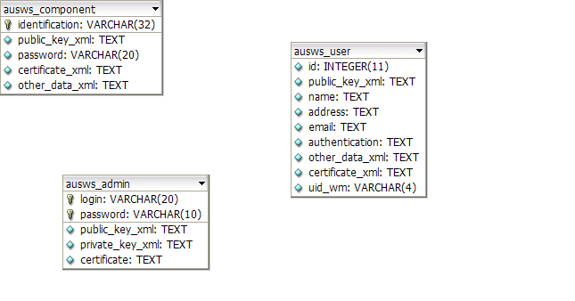

ausws_admin
ColumnName | DataType | PrimaryKey | NotNull | Flags | Default Value | Comment | AutoInc
login | VARCHAR(20) | PK | NN
password | VARCHAR(10) | PK | NN
public_key_xml | TEXT |  | NN
private_key_xml | TEXT |  | NN
certificate | TEXT |  | NN

IndexName | IndexType | Columns
PRIMARY | PRIMARY | login  password

ausws_component
ColumnName | DataType | PrimaryKey | NotNull | Flags | Default Value | Comment | AutoInc
identification | VARCHAR(32) | PK | NN
public_key_xml | TEXT |  | NN
password | VARCHAR(20) |  | NN
certificate_xml | TEXT
other_data_xml | TEXT

IndexName | IndexType | Columns
PRIMARY | PRIMARY | identification

ausws_user
ColumnName | DataType | PrimaryKey | NotNull | Flags | Default Value | Comment | AutoInc
identification | VARCHAR(32) | PK | NN
login | VARCHAR(20) | PK | NN
password | VARCHAR(20) | PK | NN
id | INTEGER(11) |  | NN
public_key_xml | TEXT |  | NN
name | TEXT
address | TEXT
email | TEXT
authentication | TEXT
other_data_xml | TEXT
certificate_xml | TEXT
uid_wm | VARCHAR(4)

IndexName | IndexType | Columns
PRIMARY | PRIMARY | identification  login  password

CFS – Configuration Service

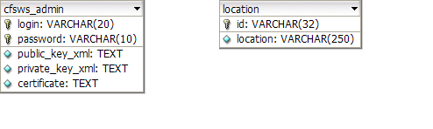

cfsws_admin
ColumnName | DataType | PrimaryKey | NotNull | Flags | Default Value | Comment | AutoInc
login | VARCHAR(20) | PK | NN
password | VARCHAR(10) | PK | NN
public_key_xml | TEXT |  | NN
private_key_xml | TEXT |  | NN
certificate | TEXT |  | NN

IndexName | IndexType | Columns
PRIMARY | PRIMARY | login  password

location
ColumnName | DataType | PrimaryKey | NotNull | Flags | Default Value | Comment | AutoInc
id | VARCHAR(32) | PK | NN
location | VARCHAR(250) |  | NN

IndexName | IndexType | Columns
PRIMARY | PRIMARY | id

COS – Commerce Service

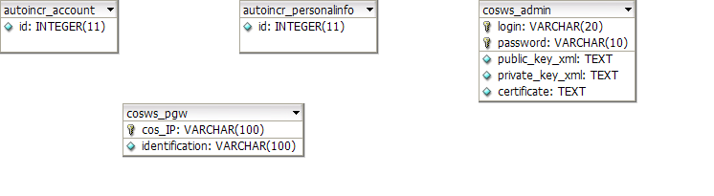

autoincr_account
ColumnName | DataType | PrimaryKey | NotNull | Flags | Default Value | Comment | AutoInc
id | INTEGER(11) |  | NN

autoincr_personalinfo
ColumnName | DataType | PrimaryKey | NotNull | Flags | Default Value | Comment | AutoInc
id | INTEGER(11) |  | NN

cosws_admin
ColumnName | DataType | PrimaryKey | NotNull | Flags | Default Value | Comment | AutoInc
login | VARCHAR(20) | PK | NN
password | VARCHAR(10) | PK | NN
public_key_xml | TEXT |  | NN
private_key_xml | TEXT |  | NN
certificate | TEXT |  | NN

IndexName | IndexType | Columns
PRIMARY | PRIMARY | login  password

cosws_pgw
ColumnName | DataType | PrimaryKey | NotNull | Flags | Default Value | Comment | AutoInc
cos_IP | VARCHAR(100) | PK | NN
identification | VARCHAR(100) |  | NN

IndexName | IndexType | Columns
PRIMARY | PRIMARY | cos_IP

CPS – Content Preparation Service

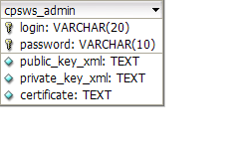

cpsws_admin
ColumnName | DataType | PrimaryKey | NotNull | Flags | Default Value | Comment | AutoInc
login | VARCHAR(20) | PK | NN
password | VARCHAR(10) | PK | NN
public_key_xml | TEXT |  | NN
private_key_xml | TEXT |  | NN
certificate | TEXT |  | NN

IndexName | IndexType | Columns
PRIMARY | PRIMARY | login  password

ITS – Protection Tools Service

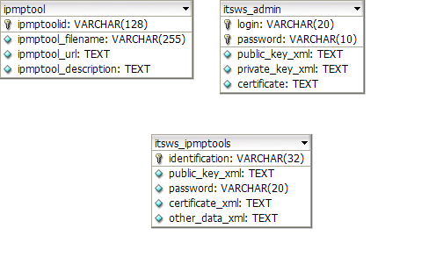

ipmptool
ColumnName | DataType | PrimaryKey | NotNull | Flags | Default Value | Comment | AutoInc
ipmptoolid | VARCHAR(128) | PK | NN
ipmptool_filename | VARCHAR(255) |  | NN
ipmptool_url | TEXT |  | NN
ipmptool_description | TEXT |  | NN

IndexName | IndexType | Columns
PRIMARY | PRIMARY | ipmptoolid

itsws_admin
ColumnName | DataType | PrimaryKey | NotNull | Flags | Default Value | Comment | AutoInc
login | VARCHAR(20) | PK | NN
password | VARCHAR(10) | PK | NN
public_key_xml | TEXT |  | NN
private_key_xml | TEXT |  | NN
certificate | TEXT |  | NN

IndexName | IndexType | Columns
PRIMARY | PRIMARY | login  password

itsws_ipmptools
ColumnName | DataType | PrimaryKey | NotNull | Flags | Default Value | Comment | AutoInc
identification | VARCHAR(32) | PK | NN
public_key_xml | TEXT |  | NN
password | VARCHAR(20) |  | NN
certificate_xml | TEXT
other_data_xml | TEXT

IndexName | IndexType | Columns
PRIMARY | PRIMARY | identification

LIS – License Service

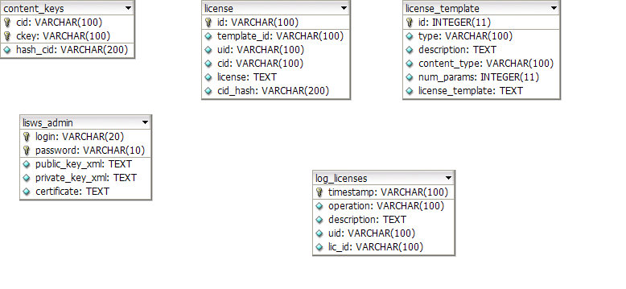

content_keys
ColumnName | DataType | PrimaryKey | NotNull | Flags | Default Value | Comment | AutoInc
cid | VARCHAR(100) | PK | NN
ckey | VARCHAR(100) | PK | NN
hash_cid | VARCHAR(200) |  | NN

IndexName | IndexType | Columns
PRIMARY | PRIMARY | cid  ckey

license
ColumnName | DataType | PrimaryKey | NotNull | Flags | Default Value | Comment | AutoInc
id | VARCHAR(100) | PK | NN
template_id | VARCHAR(100) |  | NN
uid | VARCHAR(100) |  | NN
cid | VARCHAR(100) |  | NN
license | TEXT |  | NN
cid_hash | VARCHAR(200) |  | NN

IndexName | IndexType | Columns
PRIMARY | PRIMARY | id

license_template
ColumnName | DataType | PrimaryKey | NotNull | Flags | Default Value | Comment | AutoInc
id | INTEGER(11) | PK | NN
type | VARCHAR(100) |  | NN
description | TEXT |  | NN
content_type | VARCHAR(100) |  | NN
num_params | INTEGER(11) |  | NN
license_template | TEXT |  | NN

IndexName | IndexType | Columns
PRIMARY | PRIMARY | id

lisws_admin
ColumnName | DataType | PrimaryKey | NotNull | Flags | Default Value | Comment | AutoInc
login | VARCHAR(20) | PK | NN
password | VARCHAR(10) | PK | NN
public_key_xml | TEXT |  | NN
private_key_xml | TEXT |  | NN
certificate | TEXT |  | NN

IndexName | IndexType | Columns
PRIMARY | PRIMARY | login  password

log_licenses
ColumnName | DataType | PrimaryKey | NotNull | Flags | Default Value | Comment | AutoInc
timestamp | VARCHAR(100) | PK | NN
operation | VARCHAR(100) |  | NN
description | TEXT |  | NN
uid | VARCHAR(100) |  | NN
lic_id | VARCHAR(100) |  | NN

IndexName | IndexType | Columns
PRIMARY | PRIMARY | timestamp

MDS – Media Delivery Service

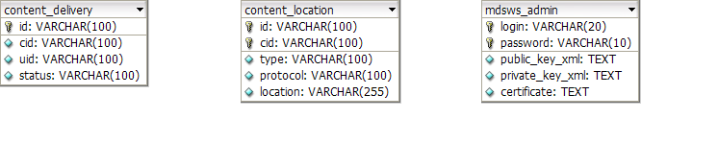

content_delivery
ColumnName | DataType | PrimaryKey | NotNull | Flags | Default Value | Comment | AutoInc
id | VARCHAR(100) | PK | NN
cid | VARCHAR(100) |  | NN
uid | VARCHAR(100) |  | NN
status | VARCHAR(100) |  | NN

IndexName | IndexType | Columns
PRIMARY | PRIMARY | id

content_location
ColumnName | DataType | PrimaryKey | NotNull | Flags | Default Value | Comment | AutoInc
id | VARCHAR(100) | PK | NN
cid | VARCHAR(100) | PK | NN
type | VARCHAR(100) |  | NN
protocol | VARCHAR(100) |  | NN
location | VARCHAR(255) |  | NN

IndexName | IndexType | Columns
PRIMARY | PRIMARY | id  cid

mdsws_admin
ColumnName | DataType | PrimaryKey | NotNull | Flags | Default Value | Comment | AutoInc
login | VARCHAR(20) | PK | NN
password | VARCHAR(10) | PK | NN
public_key_xml | TEXT |  | NN
private_key_xml | TEXT |  | NN
certificate | TEXT |  | NN

IndexName | IndexType | Columns
PRIMARY | PRIMARY | login  password

PGW – Billing Service

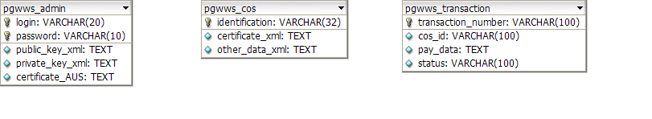

pgwws_admin
ColumnName | DataType | PrimaryKey | NotNull | Flags | Default Value | Comment | AutoInc
login | VARCHAR(20) | PK | NN
password | VARCHAR(10) | PK | NN
public_key_xml | TEXT |  | NN
private_key_xml | TEXT |  | NN
certificate_AUS | TEXT |  | NN

IndexName | IndexType | Columns
PRIMARY | PRIMARY | login  password

pgwws_cos
ColumnName | DataType | PrimaryKey | NotNull | Flags | Default Value | Comment | AutoInc
identification | VARCHAR(32) | PK | NN
certificate_xml | TEXT
other_data_xml | TEXT

IndexName | IndexType | Columns
PRIMARY | PRIMARY | identification

pgwws_transaction
ColumnName | DataType | PrimaryKey | NotNull | Flags | Default Value | Comment | AutoInc
transaction_number | VARCHAR(100) | PK | NN
cos_id | VARCHAR(100) |  | NN
pay_data | TEXT |  | NN
status | VARCHAR(100) |  | NN

IndexName | IndexType | Columns
PRIMARY | PRIMARY | transaction_number

RGW – Registration Service

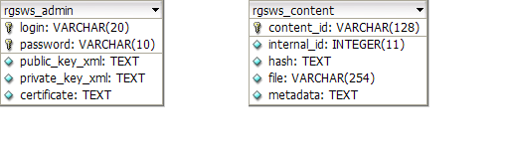

rgsws_admin
ColumnName | DataType | PrimaryKey | NotNull | Flags | Default Value | Comment | AutoInc
login | VARCHAR(20) | PK | NN
password | VARCHAR(10) | PK | NN
public_key_xml | TEXT |  | NN
private_key_xml | TEXT |  | NN
certificate | TEXT |  | NN

IndexName | IndexType | Columns
PRIMARY | PRIMARY | login  password

rgsws_content
ColumnName | DataType | PrimaryKey | NotNull | Flags | Default Value | Comment | AutoInc
content_id | VARCHAR(128) | PK | NN
internal_id | INTEGER(11)
hash | TEXT |  | NN
file | VARCHAR(254) |  | NN
metadata | TEXT

IndexName | IndexType | Columns
PRIMARY | PRIMARY | content_id

